**Final Project Report**

Student Name: James Braznell

Student Number: 1007022

Location/Site: Wolverhampton City Campus

Module Code: 6CS007

Module Name: Professionalism and Project

## Project Title:

What database technologies are emerging to handle incredibly large size of data?

Module Leader Name: D.I.Beardsmore

Supervisor Name: Sherin Nassa

Reader Name: Carl Dudley

Submission Date: 03/05/13

## Award Title : BSc(Hons) Computer Science

**Declaration Sheet**

Presented in partial fulfilment of the assessment requirements for the above award.

This work or any part thereof has not previously been presented in any form to the University or to any other institutional body whether for assessment or for other purposes. Save for any express acknowledgements, references and/or bibliographies cited in the work. I confirm that the intellectual contents of the work is the result of my own efforts and of no other person.

It is acknowledged that the author of any project work shall own the copyright. However, by submitting such copyright work for assessment, the author grants to the University a perpetual royalty-free licence to do all or any of those things referred to in section 16(i) of the Copyright Designs and Patents Act 1988. (viz: to copy work; to issue copies to the public; to perform or show or play the work in public; to broadcast the work or to make an adaptation of the work).

Student Name (Print): JAMES BRAZNELL

Student Number: 1007022

Signature: James Braznell Date: 03/05/13

(Must include the unedited statement above. Sign and date)

Please use an electronic signature (scan and insert)

**Abstract**

This project is based on the emerging technologies that attempt to handle big data in several different ways and in varying levels of competency, research has been carried out on several systems and a selection have been chosen to attempt testing on them to determine their performance, efficiency and ease of use, certain technologies however are unavailable for testing and so they have included as part of the research to be taken into consideration for answering the academic question but as they will not be tested they cannot be a part of the artefact as no work has been undertaken in order to determine their performance, efficiency and ease of use and in doing so justify the research used to ultimately answer the academic question. Therefore based on insights gained from this as well as views from respective organisations and their reports, the research and recommendations based on this and the results of the artefact will be presented in order to help companies wishing to make use of big data by reaping the benefits big data analysis brings as well as answering an important academic question that should serve as an indication of where the advances in big data analysis are heading.

**Contents**

**Title page -** Page 1

**Declaration** **Sheet** - Page 2

**Abstract -** Page 3

**Contents page -** Page 4

**Introduction** – Page 5-7

**Literature Review** –Page 8-16

**Artefact and supporting information** – Page 17-21

**Academic question answer** – Page 22-26

**Conclusion** – Page 27

**Critical evaluation** – Page 28

**References and Bibliography –** Page 29-32

**Appendices** – Page 33-46

**Introduction**

Academic Question:

Which of the emerging database technologies best handle the problem of collecting, storing and analysing incredibly large size of data?

Aims:

To research the emerging database technologies and from this create an artefact that can be tested against other current systems to determine what technologies best handle incredibly large size of data.

To create a report based on testing of the artefact that details the opportunities that can be gained from exploiting big data and what type of businesses can benefit from investing in a system capable of handling big data.

To research the technologies that are currently in development, which have yet to be fully adopted and from this create a prediction of where the developments in the handling of big data is heading.

Objectives:

Research big data origins and predictions of future solutions

Research the Hardware specifications needed to efficiently handle big data

Research the emerging database systems for a data storage system which can handle incredibly large size of data

Research the data that is most useful to a business looking to exploit big data

Research how this data can help a business make better decisions

Research the emerging applications that can handle the analysis of incredibly large size of data

Research the current benchmarks for systems that handle incredibly large size of data

Implement a data storage system capable of handling incredibly large size of data

Create a substantial amount of test data that can be used to assess the efficiency of the artefact

Test the data storage system with the newly acquired test data for speed and efficiency

Employ a system to analyse this data in a graphical representation

Test the end data collected with targeted queries

From the results generated from testing and analysing the data evaluate the artefact

Report on the database technologies currently in development and create a prediction of where the developments in the handling of big data are heading

Give conclusions of the project and critically evaluate all aspects

This project will show the a design for collecting, storing and analysing what is known as ‘big data’, big data is information from a variety of different sources such as web blogs, location data, network probes, radio frequency identification feeds, sensor data, social media feeds etc. information that a business would not normally be interested in much less have the capabilities to use in any meaningful way until quite recently.

Financial businesses can use locational data, social media and spend patterns to identify fraudulent transaction attempts to make a decision when to stop a credit card. Therefore this will give businesses that choose to use big data further information which keeps them more informed and helps them to make better decisions.

Big data comes in several forms such as incredibly large size of data, 'unstructured data' or both, several technologies have attempted to handle big data in its entirety or one of its forms, the design I create will show an adequate solution to this via the testing of several technologies and comparisons to previously performed benchmarks from reputable organisations.

However while there are great benefits to the acquisition and analysis of big data there are also issues as well, there are privacy concerns for example as information collected regarding a person's health, location, electricity use, and online activity is studied for trends that could improve a person's quality of life in the health sector for example, this raises concerns about profiling, discrimination, exclusion, and loss of control. Usually with this type of data, companies would use a variety of methods to achieve de-identification such as anonymization, encryption, data sharding etc, in order to distance data from identities of real individuals and therefore allow the analysis to continue while avoiding any privacy concerns that comes with this type of data. Even still it has been shown more recently that even when this data has been successfully anonymized it can often be re-identified and linked to specific individuals. Therefore the implications for government and businesses can be harsh, as de-identification is a key component for many businesses, mostly notably in the health sectors data stores, for example clinical trials etc, as well as online behavioural advertising, and cloud computing data, therefore it is clear that although big data is very useful those looking to reap the big data rewards must consider the concerns that come with the data that is inevitably collected and analysed, this is supported by the work of Tene, O. and Polonetsky, J. (2012).

There are several new technologies that are emerging to handle such a large size of data such as No SQL databases, oracles Exadata, hadoop, map reduce and many more. There are many benefits to an organisation which chooses to invest in a system that can make use of big data, retailers for example can use this data to micro segment their customer base and use sentiment analysis give targeted offers via social media feeds and customer data thereby delivering better revenue and margins.

The report includes a literature review of all the sources I have found which I have used in one way or another in the creation of my artefact or is to be used in this report to help answer the academic question and provide a solution my project aims, therefore these sources will be reviewed, analysed, compared and evaluated.

The report also includes full details of the Artefact, supporting information and the answer I have derived to my projects academic question. The report will contain my conclusions with reference to the initial aims of the project and academic question. Also a critical evaluation of the everything I have produced, such as the final report, results, the artefact, the process, planning, management, quality of sources and my self-reflections. Lastly the report will include all my references in a bibliography and the appendices to the final report.

**Literature Review**

Arneil, J. (2012) My Year With Exadata. *Cover Art: UK Oracle User Group Conference 2012*  [online]. ICC Birmingham 3-5 December. e-DBA.

Password: CONF2012OUG [Accessed 08 December 2012] Available at:

# <http://2012.ukoug.org/presdisplayfile.asp?prs_prsid=7038&filename=UKOUG%5FOCT%5FMy%5Fyear%5Fwith%5FExadata%2Eppt>.

This source is quite useful as it gives a consumers perspective on Exadata, a summary of exactly what Exadata is, their experiences from the set up, it also goes into detail on the technical specifications of Oracles newly released Exadata X3 which improves greatly on previous versions and finally sheds light on the hardware and software maintenance needed to keep Exadata running. This source is similar to the work of (Kutrovsky 2012) which also goes into detail on Exadata however the source focuses more on the software side for example how the data moves in Exadata while this source is more focused on the new hardware changes with this latest instalment of Exadata. The source therefore provides useful information and does not come directly from Oracle so it is less likely to be biased about Exadata advantages and disadvantages, therefore this source will help answer the academic question and achieve the aims as supporting material to the research on the emerging database systems, it will be useful to compare them to Oracle's system for handling big data, as well as being incorporated into the report.

Borkar, R, V., Carey, J, M. and Li, C. (2012). Big data platforms: What's next?. *XRDS: Crossroads*, [online]. **19**(1), pp.44-49 [Accessed 15 February 2013]. Available at:

<http://delivery.acm.org.ezproxy.wlv.ac.uk/10.1145/2340000/2331057/p44-borkar.pdf?ip= 134.220.1.139&acc=ACTIVE%20SERVICE&CFID=281029974&CFTOKEN=14962939&__acm__=1361652571_a266ed3632371081205a63df4ca9716f>

# This source describes the current status of big data, how it is being used, the history behind it, the source describes several technologies that have emerged to deal with big data such as MapReduce framework, Hadoop, BigTable, dynamo, HBase, Cassandra, Hive, Pig. The source then looks the future and introduces its own system ASTERIX, a big data management system (BDMS), the system is described and is compared to several other big data technologies showing how big data systems have advanced over the years. The source is quite useful as it shows what big data is used for, the technologies that deal with it and a new technology that takes advantage of the developments in big data technology, similar to the work of Tene and Polonetsky (2012), both sources describe big data in detail however this source focuses more on the technology for handling big data while the previously referenced source focuses more on the issues with big data. This source will help answer the academic question and achieve the aims when it is used to help create the artefact and to make a better decision on its configuration as well as in the final report for the evaluation of the completed artefact.

Bhatewara, A., Waghmare, K. (2012). Improving Network Scalability Using NoSql Database. *International Journal of Advanced Computer Research*, [online]. **2**(6), pp.488-490 [Accessed 21 February 2013] Available at: <http://www.theaccents.org/ijacr/papers/conference/icett2012/87.pdf>

# The source describes technologies more suited to the unstructured nature of big data in this case for use in the cloud such as NoSQL database and Cassandra, it shows the advantages and disadvantages of each and how they compare to a RDBMS. This source is useful as it shows that if higher scalability is needed without upgrading hardware, these technologies are a viable option for this, similar to the work of Stonebraker (2012), they both show technologies that can give the user greater performance when dealing with big data however this source evaluates NoSQL and Cassandra while comparing them to RDBMS which the previously referenced source does not. This source will help answer the academic question and achieve the aims by being used as reference when creating the artefact and when evaluating it in the final report.

# Brooks, J. (2011). **Oracle** Gives **NoSQL** Market a Boost. *eWeek*, [online]. 28(17), pp.8 [Accessed 27 February 2013] Available at:

# <http://wk6kg9sd8m.search.serialssolutions.com/?ctx_ver=Z39.88-2004&ctx_enc=info%3Aofi%2Fenc%3AUTF-8&rfr_id=info:sid/summon.serialssolutions.com&rft_val_fmt=info:ofi/fmt:kev:mtx:journal&rft.genre=article&rft.atitle=Oracle+Releases+NoSQL+Database+Linked+to+2012+Big+Data+Appliance+Launch&rft.jtitle=eWeek&rft.date=2011-10-24&rft.pub=Ziff+Davis+Enterprise&rft.issn=1530-6283&rft.externalDBID=n%2Fa&rft.externalDocID=270709934>

# 

# This source describes the events at Oracle OpenWorld 2011, where Oracle announced its own NoSQl database, this is useful as it provides me with information on another big data technology that may be included into my artefact, Oracle NoSQL is shown to be based upon the Java version of Oracle's BerkeleyDB, as well as being included with services such as supporting scale-out over large numbers of nodes. This source is similar to the work of Henschen, D. (2011), they both give a background of Oracle's NoSQL database and show how it is based upon previous technologies however this source is simply based upon the technology itself and briefly mentions competitor technologies while the previously mentioned source details Oracle's NoSQL database in the context of big data as well as comparing the technology to Cassandra, which this source does not. This source will help answer the academic question and achieve the aims by being used as reference when creating the artefact and when evaluating it in the final report.

# Clegg, D. (2012) Formulating Your Big Data Strategy: It's Not About Technology - It's About Business Value; It's Not About Data - It's About Insight from Data. *Cover Art: UK Oracle User Group Conference 2012* [online]. ICC Birmingham 3-5 December. Acunu.

Password: CONF2012OUG

# [Accessed 08 December 2012] Available at: <http://2012.ukoug.org/presdisplayfile.asp?prs_prsid=7013&filename=121203UKOUG%2Epdf>.

# This source outlines what the market is using to handle their big data needs, such NoSQL, Hadoop etc and shows exactly what kind of uses they are popular for, such as on-line big data workloads, batch processing. It also shows why RDBMS are not able to handle the issue of big data and how a good analytics program will help to sift through big data to find exactly what is needed. This source is similar to the work of (Howard *et al* 2012) as the source goes into detail on analytics, the uses and benefits therein it also gives a presentation of an analytics program in use unlike this source which provides greater clarity to analytics. This source provides a decent amount of information about the big data solutions currently on the market although it could be considered biased by advertising its own analytics program, however it will still be useful and therefore this source will help answer the academic question and achieve the aims as supporting material to the research on the emerging database systems that can handle big data and by being included in the report.

Davis, M. A. (2012). NoSQL Equals NoSecurity. *InformationWeek*, [online]. Apr 9, 2012, pp.29-31 [Accessed 26 February 2013] Available at:

<http://search.proquest.com.ezproxy.wlv.ac.uk/docview/1011104685/fulltextPDF?accountid=14685>

The source shows that while technologies like NoSQL and Hadoop are more widely used for their ability to handle big data, it is clear that security is an issue that may have been overlooked. It details how several forms of NoSQL databases are being adopted as well as the use of MapReduce and BigTable to handle big data however security is very lax due to the advancements in such technologies coming from the developers who have so far have not seen fit to add proper security measures to such technologies. It recommends security controls for developers to implement for the database as well as security recommendations for the operating system (OS) and concludes that companies must take more responsibility in terms of security. This source is very useful as it provides a great deal of information on the security issues of big data technologies especially NoSQL databases which are similarly detailed in the work of Tene and Polonetsky (2012). However in contrast to this source the previously referenced source details a background on big data as well as the benefits of big data analysis which this source does not. Therefore this source is very useful as a change from the benefits of big data technologies and it will help answer the academic question and achieve the aims by using during the creation of the artefact and in the report when considering the security issues with big data and the artefact.

Gu, Y., Shen, S., Zheng, G. (2011). Application of NoSQL Database in Web Crawling, *International Journal of Digital Content Technology and its Applications,* [online]. **5**(6), pp.261-266 [Accessed 13 March 2013] Available at:

<http://www.aicit.org/JDCTA/ppl/31_%20JDCTA_June-35.pdf>

This source details an important application of the internet, web crawling, which is the filtering and collection of numerous resources/information from the internet based on a certain theme, this is then stored in a database and a search engine is created. This source does not directly relate to big data, although it does mention how the amount of data being collected and stored is growing fast and therefore databases must expand in size in order to meet this influx of data without affecting query performance, therefore the database must still perform as well as if it had not been expanded and stored with much more data than before. From there the source details how traditional relational systems store data and how they have dominated all areas of database applications. Then the source introduces NoSQL databases as non-relational data storage and details its history starting from 1991 with BerkeleyDB a a key/value database for when a great speed of inserting, reading and writing with a fairly simple data type is required. It also details the design philosophy of NoSQL databases as reducing the data consistency and integrity constraints and trading this for great availability and scalability in order to meet the requirements of large data storage, high performance and low-cost scalability. The source also gives examples of several NoSQL databases such as Apache’s HBase, Google’s BigTable, 10gen’s MongoDB, Facebook’s Cassandra and Yahoos PNUTS and details these sources as high performance of read and write and scalability. The source similar to the work of Schmutz, G. (2012), who also goes into detail on NoSQL technologies, but focuses more on how they can be used to deal with the issue of big data while this source focuses more on how this can help with the web crawling application used for the creation of search engines. This source will help answer theacademic question and achieve the aims by being used as reference when creating the artefact and when evaluating it in the final report.

Henschen, D. (2011). Oracle Releases NoSQL Database, Advances Big Data Plans. [online]. New York: InformationWeek [Accessed 23 February 2013]. Available at:

<http://search.proquest.com.ezproxy.wlv.ac.uk/docview/900341996>

This source details the release of several big data technologies based on the open source Apache Hadoop project, however the source focuses on NoSQL database's more specifically Oracles NoSQL database which it mentions is based on the open source BerkeleyDB and the Sleepycat Software from 2006. This is useful as it provides me with background information on Oracle's NoSQL database as well as comparing this to alternative big data technologies such as Cassandra. This source is similar to the work of Brooks, J. (2011), both sources detail a background of Oracle's NoSQL database and show how it is based upon previous technologies however this source details Oracle's NoSQL database in the context of big data as well as comparing the technology to Cassandra, however the previously referenced source also details the technology itself but not from a big data standpoint and it also mentions competitor technologies such as MongoDB and CouchDb which this source does not. This source will help answer theacademic question and achieve the aims by being used as reference when creating the artefact and when evaluating it in the final report.

# Howard, P., Sowerby, D. (2012) *The Next BIG Thing?* *Cover Art: UK Oracle User Group Conference 2012* [online]. ICC Birmingham 3-5 December. SolStonePlus.

Password: CONF2012OUG [Accessed 08 December 2012] Available at: <http://2012.ukoug.org/presdisplayfile.asp?prs_prsid=7491&filename=SolStonePlus%5F%5FUKOUG%5FConference%5FEndeca%5FPresentation%5F2012%2Epptx>.

This source explains what Big data is and how it should be used, it goes on to show how a graphical representation of such data can help to see exactly what you are getting from the data you have collected and stored. This is useful as it provides me with background information on big data and demonstrates how a graphical representation of my artefacts results could help understand the outcome when testing my artefact. This source is similar to the work of Tene, O. and Polonetsky, J. (2012) which also provides a detailed background on big data, however it also shows the possible benefits big data can grant with several examples as well as the concerns with big data with several examples which this source does not therefore the previously referenced source gives a more detailed account of big data. The source provides adequate background information on Big data and a demonstration of analytics tools, therefore this is a useful source and it will help answer the academic question and achieve the aims by furthering the research and will by being included in the report.

Kutrovsky, C. (2012) Exadata Data warehousing: Leveraging Parallel Query. *Cover Art: UK Oracle User Group Conference 2012* [online]. ICC Birmingham 3-5 December. Pythian.

Password: CONF2012OUG

[Accessed 08 December 2012] Available at:

<http://2012.ukoug.org/presdisplayfile.asp?prs_prsid=7482&filename=Christo %5FKutrovsky%5F%2D%5FExadata%5FDatawarehousing%5FLeveraging%5FParallel%5FQuery%5F%2D%5F2012%2Epptx>.

The source details the inner workings of Exadata, specifically how the data moves in order to get a result; it describes parallel query concepts including a big sort, group by and join which is useful when dealing with very large tables. There are many useful points in this source that helps to shed light on how Exadata works to give the best result, compared to other sources this source gives the reader a fair amount of information on Exadata similar to the work of Logan and Abbey (2012), which also provides an adequate amount of information on big data and oracles Exadata. This source will help answer the academic question and achieve the aims by being used in the final report when comparing the artefact to Exadata.

Logan, P., Abbey, M. (2012) Applying Traditional DBA Skills to Oracle Exadata. *Cover Art: UK Oracle User Group Conference 2012* [online]. ICC Birmingham 3-5 December. Pythian.

Password: CONF2012OUG

[Accessed 06 December 2012] Available at:

<http://2012.ukoug.org/presdisplayfile.asp?prs_prsid=7213&filename=exadata% 5Fukoug12%5Fpost%5Fabbey%5F%2D%5FPaul%5FLogan%2Epptx>.

The source compares and contrasts a relational database management system (RDBMS) to Exadata and how Exadata works to get the most performance possible, backup considerations, the internals of the Exadata machine, functions for compression, performance and storage, this shows what is new with Exadata and how it can help deal with big data. There are useful points in the source which when compared to the work of Howard and Sowerby (2012), which in contrast to this source provides the reader with less information than is expected. This source will help answer the academic question and achieve the aims by helping tocomparing the artefact against Exadata in the final report.

Mone, G. (2013). Beyond Hadoop. *Communications of the ACM*, [online]. **56**(1), pp.22-24 [Accessed 12 February 2013] Available at:

<http://wk6kg9sd8m.search.serialssolutions.com/?ctx_ver=Z39.88-2004&ctx_enc=info%3A ofi%2Fenc%3AUTF-8&rfr_id=info:sid/summon.serialssolutions.com&rft_val_fmt=info:ofi/fm t:kev:mtx:journal&rft.genre=article&rft.atitle=Beyond+Hadoop.%28Apache+Hadoop%27s+continuous+evolution%29%28News+%2F+Technology%29&rft.jtitle=Communications+of+the+ACM&rft.au=Mone%2C+Gregory&rft.date=2013-01-01&rft.pub=Association+for+Computin g+Machinery%2C+Inc&rft.issn=0001-0782&rft.eissn=1557-7317&rft.volume=56&rft.issue=1 &rft.spage=22&rft.externalDBID=n%2Fa&rft.externalDocID=316952108>

# This source shows how Hadoop continues to be used as a leading technology for handling big data, it describes the history and structure of Hadoop as well as mentioning several technologies that add onto or focus more on certain aspects of Hadoop such as, MapR, Pregel, GraphLab, HBase, Cloudant, Dremel for example and gives a description of each. This source is useful as it shows a different side to Hadoop where although it will handle the issue of big data but it alone does not allow for the tools needed to reap the benefits from analysing such data, similar to the work of Borkar et al. (2012), both sources give detailed information on several technologies that handle big data however this source does not go into detail on big data itself while the previously referenced source does and this source focuses on hadoop and its offshoots, while the previously referenced source branches out to several different big data technologies. This source will help answer the academic question and achieve the aims when used as guidance when creating the artefact and in the report during the evaluation of the artefact.

Russom, P. (2011) Big Data Analytics. *October*, [online]. **19**(40), pp.1-40 [Accessed 12 March 2013] Available at:

<ftp://129.35.224.12/software/tw/Defining_Big_Data_through_3V_v.pdf#page=6>

# This source details the issue of big data from the perspective of analytics, the source gives an introduction to the world of big data analytics, shows the current shape of big data analytics in general such as their adoption, benefits, issues etc, it also shows best practices for big data analytics something which would be invaluable when trying to make use of big data. This source is useful as it details information on both big data and the analytics programs used to discover trends in the data. This is similar to the work of Clegg, D. (2012) as both sources detail analytics in terms of big data however while this one provides the reader with a lot of detail on analytics which the previously referenced source does lack, but it does give a graphical representation of an analytics program which is quite useful to those wishing to make use of big data. This source will help answer the academic question and achieve the aims when used in the report during the evaluation of the artefact.

Schmutz, G. (2012) NoSQL Databases for Implementing Data Services – Should I Care? *Cover Art: UK Oracle User Group Conference 2012* [online]. ICC Birmingham 3-5 December. Trivadis.

Password: CONF2012OUG

[Accessed 10 December 2012] Available at:

<http://2012.ukoug.org/presdisplayfile.asp?prs_prsid=7424&filename=nosql%2Ddatabase%2Dfor%2Dimplementing%2Ddata%2Dservices%2Dshould%2DI%2Dcare%2Epdf>.

The source gives a perspective on NoSQL databases, a background, reasons for using it instead of a RDBMS, a description of different NoSQL databases, a comparison to RDBMS, it shows a different form of programming called Polyglot Programming used for taking advantage of many different languages advantages when tackling different problems and how this can be applied to database systems. This source is similar to the work of Bhatewara and Waghmare (2012). Both sources show in great detail technologies that handle the issue of big data and details why these are used over a traditional RDBMS, this source will help answer the academic question and achieve the aims when constructing the artefact as well as to be used in the final report.

Stonebraker, M. (2010). SQL databases v. NoSQL databases. *Communications of the ACM*, [online] **53**(4), pp.10-11 [Accessed 22 February 2013] Available at:

<http://mags.acm.org.ezproxy.wlv.ac.uk/communications/201004/?folio=10&CFID=281029974&CFTOKEN=14962939#pg1>

# The source describes the reasons for using a NoSQL database and how to get better performance for online transaction processing (OLTP) databases by removing the 'overhead' or traditional aspects of Atomicity, Consistency, Isolation, Durability (ACID) which is grouped into four parts in OLTP databases, for example; logging, locking, latching and buffer management these points are given descriptions for clarity. Therefore this source is quite useful as it shows the differences between RDBMS and NoSQL databases and how NoSQL allows for greater performance, similar to the work of Schmutz (2012) which also gives its perspective on NoSQL databases and similarly compares it to RDBMS, however this source shows how NoSQL database gives the user greater performance over RDBMS which the previously referenced source does not. This source will help answer the academic question and achieve the aims by using this source when creating the artefact and in the final report during the evaluation of the artefact.

Taylor, R. (2010). An overview of the Hadoop/MapReduce/HBase framework and its current applications in bioinformatics, BMC Bioinformatics, [online], **11**(Suppl 12), pp.S1 [Accessed 15 March 2013] Available at: <http://www.biomedcentral.com/content/pdf/1471-2105-11-S12-S1.pdf>

This source details an overview of several technologies such as Hadoop and other technologies that are reliant on Hadoop such as MapReduce, HBase, Hive, Pig etc in the concept of ultra large scale data set analysis. This source mentions how this analysis is a developing issue and that open source software has been developed to be able to scale to petabyte level in order to deal with this issue. The source also gives an overview of the current uses of hadoop and its reliant technologies, as well as a conclusion on the usefulness of Hadoop and its reliant technologies, stating them to have a substantial base and is cost effective based analysis on commodity clusters. This source is similar to the work of Mone, G. (2013) who also details on Hadoop and technologies that add on to Hadoop, however this source focuses more on data storage add-ons while the previously referenced source deals more with distributed, cloud based add-ons. This source will help answer the academic question and achieve the aims by using this source when creating the artefact and in the final report during the evaluation of the artefact.

Tene, O., Polonetsky, J. (2012). Privacy in the Age of Big Data: A Time for Big Decisions. *Stanford Law Review Online*, [online] **64**(63), pp.63-69 [Accessed 19 February 2013].

Available at: <http://www.stanfordlawreview.org/online/privacy-paradox/big-data>

The source details a background on big data and how it has relatively recently come into the spotlight, it show the benefits big data can grant such as in the health sector, data can be analysed to attribute health issues to previously unknown causes, big data can also be analysed to predict flu outbreaks or energy demands for example. The concerns with big data are detailed such as protecting privacy and data security and therefore governments and businesses must be aware of this issue. The source therefore is quite useful and raises some issues that come with big data as well as its benefits, similar to the work of Borkar et al. (2012). This source gives the reader a background on big data, benefits etc which is similar to the previously referenced source, however this source also shows the privacy and security concerns with big data which is in contrast to the previously referenced source as it does not mention this.This source will help answer the academic question and achieve the aims by providing background knowledge for the project but also for use in the final report.

Yuan, X., Vega, P., Qadah, Y., Archer, R., Yu, H., Xu, J. (2010). Visualization Tools for Teaching Computer Security. *ACM Transactions on Computing Education*, [online] **9**(4), pp.12-13 [Accessed 29 February 2013]. Available at:

<http://williams.comp.ncat.edu/IA_visualization_labs/publications/visualization%20tools-yuan.pdf>

This source details in depth information on the third part authentication service 'Kerberos' which many NoSQL databases support in order to improve on their lack of security, this source is quite useful as it provides me with detailed knowledge on a piece of the security used by many NoSQL databases on the market. This source is similar to the work of Schmutz, G. (2012) as this source details a background on NoSQL databases but also shows the issues specifically security issues with NoSQL databases which this source does not, it mentions Kerberos as a partial solution to this issue but does not go into much detail into the technology itself which this source does. This source will help answer the academic question and achieve the aims by being used when creating the artefact and in the final report during the evaluation of the artefact.

**Artefact Details**

During this project much research has been produced on the systems emerging to handle big data, from this research, systems have been chosen that appear to best handle this issue of big data but also are usable and available within the constraints of the project and the limitations of hardware to handle big data. Therefore the first system chosen to test was Oracle NoSQL Database, this system is different to traditional relational database management systems (RDBMS), which are quite popular in industry because of several factors such as the SQL (Structured Query Language) language which is an effective declarative query language designed for the management of data in relational databases, also the inherent referential integrity which enforces valid data entry into the database. Another factor is the ACID(Atomicity, Consistency, Isolation, Durability) standard for transactions which is prevalent in relational databases, Atomicity maintains that all operations of a transaction be completed or it will fail, consistency is that a transaction must leave the database in a consistent state and all data is valid within the databases defined rules, isolation is that data will be unavailable or 'locked' during a transaction for other transactions until the first transaction is completed, durability is that once a transaction has successfully completed or 'committed' it is permanent. The ACID principle is used to maintain a database has a reliable transaction system which is very important in RDBMS (Relational Database Management Systems) for OLTP (Online Transaction Processing) databases.

Another factor for relational databases popularity is that is generally understood and accepted by developers, database administrators(DBAs) due to the amount of support available in terms of languages, frameworks, tools such as Hibernate, JPA, JDBC, iBATIS, Entity Framework for example. Also the database administrators have several options in terms of configuration of the database's properties, monitoring of the database for errors or bugs, backup in case of data loss and recovery should data be lost, tuning of the database for greater performance for example when querying data, design of the database to best meet the needs of the company the database is for. However relational databases do have issues for example in terms of complex object graphs where there could be object/relational impedance mismatch, it is complicated to map rich domain model to relational schema, general performance issues, there will be many rows in many tables, many joins etc. Also there is an issue with schema evolution for example adding attributes to an object such as having to add columns to a table, it is expensive, if there is a lot of data in that table, locks can be held on the tables for a long time essentially making the tables unavailable for the entire time they are locked. Another issue is to do with semi-structured data, as the relational schema doesn‘t easily handle semi-structured data, there are solutions such as a name or value table however this causes poor performance and lack of constraint. One important issue with relation databases is Scaling as the writes become difficult, expensive or even impossible especially when dealing with big data also vertical and horizontal scaling is limited and is expensive so this is not a true solution to scaling in relational systems.

NoSQL databases however or 'Not Only SQL' don‘t use the relational data model and therefore don‘t use SQL, they are generally open source and are designed to run on a cluster of machines for greater performance, they also do not have any fixed schema therefore they can store any data in any record and have different application programming interfaces (APIs). They do not conform to the ACID standard for transactions that is prevalent in relational databases this is supported by the work of Stonebraker, M. (2010). In a NoSQL database the ACID properties are removed for performance gains, which is useful when dealing with big data where performance is a constant factor and transactions are generally less frequent than in OLTP databases as big data can be compared to a data warehouse with a huge amount of data that is simply queried for data analysis, therefore the ACID standard is less important in this case. NoSQL databases became increasingly popular when scalability became an issue for those using relational databases especially major internet companies such as Google, Amazon and Facebook for example, they realized that they did not require consistency as much as they needed scalability and performance therefore NoSQL became popular for dealing with this issue, this is supported by the work of Bhatewara, A. and Waghmare, K. (2012).

NoSQL databases come in several forms such as key value stores, these are essentially data structures for the implementation of an associative array, a structure maps keys to values. Key value stores are mostly used when access to the database is via primary keys, based on the API they are the simplest NoSQL data stores available, the value is a blob and the data store does not know what is inside, they are aggregate oriented and generally used for user profiles, preferences or shopping cart data etc.

Another form of NoSQL databases is column-family stores, they store data in column family's as rows that have many columns associated with a row key, these column family's are groups of related data, often accessed together, they are aggregate oriented and generally used for event Logging, counters etc. One such example of this is Cassandra, a transactional NoSQL database, this allows it to regularly make schema changes and add new attributes and features to profiles and social network interactions. Cassandra is an open source piece of software and designed to scale out on commodity hardware therefore it is a low cost option, this is supported by the work of Henschen, D. (2011). Also unlike in relational tables if there isn't a value for a particular column, instead of using a 'null' value Cassandra instead allows a name/value pair to be omitted should there be no value, this is supported by the work of Bhatewara, A. and Waghmare, K. (2012).

Another form of NoSQL database is document databases, they store and retrieve documents, in several file types such as XML for example, the documents are self-describing, hierarchical tree data structures which can consist of maps, collections and scalar values, these documents stored are similar to each other but do not have to be exactly the same, they are aggregate oriented and generally used for event logging, web analytics or real-time analytics, product catalogue etc. Another form of NoSQL database is graph databases, these allow the storage of entities and relationships between these entities, these entities are known as nodes, relations are known as edges and a query on the graph is also known as traversing the graph, traversing the relationships is very fast, they are generally used for connected data, routing, dispatch and location-based services, recommendation engines etc, this is supported by the work of (Schmutz, G. 2012).

However while NoSQL databases provide great flexibility in terms of the data it can handle and blinding performance without a traditional relational systems overheads slowing it down, there are consequences to using such systems such as the lack of tool and framework support, there is little or no support for ad-hoc queries for example. There are also security issues with NoSQL databases as generally only basic security is provided if at all, firewalls are trusted to safeguard data for example, but most NoSQL databases support 'Kerberos' which provides slightly better protection, Kerberos is a trusted third-party authentication service. It provides a centralized authentication server to authenticate users to servers and vice versa. It uses symmetric encryption with keys shared with the authentication server. All communications between the two parties are then encrypted with the session key, this is supported by the work of Yuan, et al (2010). The reason for these security issues is because NoSQL databases were originally not intended for sensitive data therefore security was not as important, developers were essentially experimenting with the performance gains they could achieve, therefore security is down to developers, also there are rapid application development frameworks such as Spring, Ruby On Rails, which provide well tested set of security features but it is clear that NoSQL databases are still lax in the security available for them, this is supported by the work of Davis, M. A. (2012).

For my Artefact, the first system installed was Oracle NoSQL database, this is a key value storage database where access to the database is via primary keys, it is based upon the open source BerkeleyDB database, as well as Sleepycat Software, this is supported by the work of Brooks, J. (2011), however while BerkeleyDB is a single-node database, Oracle NoSQL includes a new programming interface and support for partitioning for highly distributed processing. Oracle's NoSQL database can run on 'commodity' hardware but it is designed with big data in mind, therefore it can come as part of a big data solution when Oracle's Exadata system is included as part of the package, this means there is a possible vendor lock-in leading to interest into alternatives such as Cassandra or MongoDB etc. Oracle NoSQL is intended for the customers who are looking for the scalability to track Web clickthroughs, smart-meter data, network management, or personalization for example, which as a NoSQL technology its scalability and schema flexibility is its primary attraction, it also comes with Oracle support for any mishaps or general guidance on the product, however Oracle NoSQl database unlike several of its competitors is not open source therefore this puts it at a disadvantage to its open source competitors, this is supported by the work of Henschen, D. (2011).

Oracle NoSQL database comes with KVLite, which is a simplified version of Oracle NoSQL Database. It provides a single-node store that is not replicated. It runs in a single process without the need for an administrative interface. KVLite can be commanded via its command line interface, it is intended for application developers to unit test their Oracle NoSQL Database application. The tool was used for testing purposes due to the limitations of

The next technology tested was MongoDB, this is a Document NoSQL Database which has previously been shown before is used to store and retrieve documents and as Schmutz (2012) has shown can be of file type XML, JSON, BSON etc, are aggregate-oriented and are useful for, event logging, web analytics or real-time analytics, product catalogues etc. Also, Gu *et al* (2011) details MongoDB as a popular NoSQL database, with the aim of being a cross between Key-value stores with their high performance and scalability with traditional RDBMS’s rich management, MongoDB has loose data structure as the data format, and provides automatic sharding to achieve mass data storage, and allows for full indexes. The query language syntax is similar to the object-oriented language. The data model is convenient to design and because it is document-oriented, documents map nicely to programming language data types, embedded documents and arrays reduces need for joins and is schema-free for easier schema changes. There are no joins and no transactions and the full indexes with indexing to embedded documents and arrays allow for great performance gains. MongoDB is easier to scale due the automatic sharding which allows for greater performance in distributed reading and writing, it will also run on commodity hardware saving money while the distributed querying allows for great performance even on low cost hardware. The query language MongoDB uses is well developed as it allows for conditional operators, regular expressions, querying on documents and arrays that are embedded, and can replace most of SQL queries, any complicated aggregate operations can be undertake n by utilizing MongoDB utility functions as well as the use of map reduce. In order to provided even greater performance gains MongoDB uses a distributed file system GridFS, which allows for clear splitting of bulky files into numerous small portions. Therefore this technology will be an important part of the artefact as the data storage system for the test data.

The installation begins by adding the 10gen GPG key was added and updating the source list as shown in figures 11-12, next the MongoDB package is installed as shown in figures 12-13, the MongoDB service starts as shown in figure 13. In a second shell a command is given to connect to the MongoDB service, a test record is inserted into the test database and queried to check the installation and connection proceeded as planned as shown in figure 14.

The testing of MongoDB begins by the creation of a new database “jamesdb”; this is achieved by simply switching to it in the mongo shell, using the command “use <insert database name>”. Next two documents are created in the database and then inserted into a collection “big1”, this collection is created simply by using the command db <insert collection name>.insert( <insert document name> ), next by using a for loop a substantial amount of test data is inserted in the “big1” collection to be tested at a later date. For testing purposes more collections are created with substantial test data inside but this adequately demonstrates the process of creating the database to hold a substantial amount of test data, this is shown in fig.15.

Next all collections are shown in the mongo shell and tested by querying each of the collections and having MongoDB explain what happened during this query, the most important aspects of this are the number of scanned objects and the amount of time the query took to run, ten of the collections each contain over a million documents, while the final collection contains over ten million documents in order to show the performance of MongoDB, this is shown in figures 16-31.

This testing of testing of MongoDB has show the sheer power of NoSQl databases and their ability to handle extremely large amounts of unstructured data, in order to compare the results of the MongoDB testing a test database has been set up on a traditional RDBMS Oracle RDBMS as shown in figures 32-33. The database model shown is a single table with three columns a primary key 'BigNo', two varchar's 'bName' and 'bCompany', this table although simple will serve to show the difference between a traditional RDBMS and NoSQL databases when filled with an adequate amount of test data in order for the test to be legitimate. The test data itself is very simple with three columns , the first ‘BigNo’ giving the unique number of each row, the second column ‘bname’ is a varchar and all but two of the values are named ‘test’, the two unique values being included for targeted queries to return only these values. The third column ‘bcompany’ is a varchar and all but two of the values are named ‘tester’, the two unique values being included for targeted queries to return only these values.

**Academic Question Answer**

Before the answering of the academic question it is important for to give an overview of those technologies that were not included in the artefact, as although they were not tested as a part of the artefact, the research gathered concerning them is still relevant and therefore essential to the answering of the academic question.

While the artefact has shown that there are technologies that can handle big data, some better and more popular than others, there is another option available to me due to the financial requirements it entails, this is Oracles Exadata their solution to big data, a combination of hardware and software engineered for this purpose, the idea with Exadata is that the storage nodes have some database code running on them so when they receive a request for data they can intelligently optimize what data is read on disk and reduce the amount of data sent back to the compute nodes. There is no other hardware running Oracle that has this therefore it is called offloading technology, the Exadata system requires high maintenance however, as it is an engineered system not appliance and should be taken into account before deciding to use this technology, this is supported by the work of (Arneil, J. 2012).

When attempting to analyse data stored in a data warehouse on a big data level, there are several solutions to the performance issue that can arise with this included in the Exadata system, Exadata is a multi-tier database system, it is compatible with several parallel queries, Big sort, big group by, big join for example which allows for even greater performance under the right circumstances, this is supported by the work of (Kutrovsky, C. 2012). There are additional benefits to Exadata such as working in SQLPlus on an Exadata system is the same as when housed on a traditional server, all of the skills learned through years of database management can be transferred over when using this technology although there are some quirks in a few areas, the learning curve is not too steep. The Exadata Machine itself contains database servers, Oracle Exadata storage servers; Infiniband fabric for storage networking, therefore this is ideally suitable for online application processing (OLAP) and online transaction processing (OLTP). There are a series of components that allow remote hardware management and data access even when other components may be inaccessible, also cell offloading, this means that work previously performed in the database tier now done at the storage tier which also increases performance, Exadata also includes hybrid columnar compression, this is the storing of column data together, with the same data type and similar characteristics and therefore this can dramatically increase the storage savings achieved from compression, this is supported by the work of (Logan *et al* 2012).

Another technology that would help with the analysis of big data is big data analytics; this is where complex advanced analytic techniques operate on big data sets in order to discover trends in the data which can be shown generally in a graphical form via charts such as a pie chart for example. With the advent of recent breakthroughs, the vendor tools and platforms give us even greater performance that is very useful for applications involving big data, therefore analytics tools and databases can now handle big data and can execute big queries and analyse tables in record time. Big data provides huge statistical samples, which enhance analytic tool results this is because generally most tools designed for data mining or statistical analysis are optimized for large data sets due to the fact that most of the time, the larger the data sample, the more accurate the results the analysis. Big data analytics is a fast-growing and significant exercise and are quite common in the business world where this is used by many organisations wishing to make use of big data. Any business dealing with customers could benefit from big data analytics. By adopting big data analytics business can benefit from better targeted marketing, customer-base segmentation, and detection of sales and market opportunities as well as a perception of customer/client behaviour. Big data analytics has benefits, but there are issues as well such as inadequate staffing and skills area common issue with big data analytics, the concept is still quite new to many businesses. Skills for architecting a big data analytics system and issues with making big data usable for end users are not as common as business intelligence or dealing with data warehouses for example. A lack of business support can hinder a big data analytics program and the overall cost of a big data analytics program is an issue as well especially for smaller businesses. Big data does give rise to technical issues due to the size and diversity, generally for most businesses the size of big data is the major hindering factor, however big data is still a great opportunity, by analysing big data, a business can detect information of their customers, markets, partners, costs and operations and use that information to the businesses advantage. In the current market it has been shown that most businesses measure analytic big data in terabytes and this is likely to soon increase to the petabyte scale. Therefore businesses dealing with big data analysis will soon have to perform planning in this area in order to make sure they can increase in scale and performance in order to continue to reap the rewards of big data analysis, this is supported by the work of Russom, P. (2011).

One such program offers several benefits to its users, Acunu analytics offers real-time analytics, continuous monitoring and instant intelligence on rapidly changing Big Data sets, it allows for the ingesting and storing of data, which from a big data standpoint should be high volume, high velocity and can come in any variety. The technology allows for the integration of other data sources, it will enrich and filter data streams at source or on ingest, there is an automatic roll up for accelerated queries, counts, averages, historical comparisons etc. The technology also allows for the use of dashboards, drill-down analysis, detection of trends and alerts, embedded results, further analysis, cumulative analytics, even support for exporting to Hadoop. This therefore would be very useful to those dealing with big data and wish to analyse and display meaningful results in the form of trends shown in graphs for example, this is supported by the work of (Clegg, D. 2012).

There are many different technologies that can adequately handle big data, my academic question has challenged me to find the best of these technologies, several different areas several different areas have been researched into such as one solution for dealing with the issue of big data that must be considered is Oracles Exadata system as has been shown previously, is a powerful tool for dealing with big data with its multi-tier database system, parallel queries, cell offloading, SQL Plus will work the same on the system as it would on a traditional server, database management skills are transferrable to Exadata, the learning curve with the technology is not too steep, hybrid columnar compression and Oracle support etc. However despite all the benefits Oracles Exadata can bring to a business that wishes to make use of big data, it cannot be said that it is the best solution to big data, it is very effective but this comes at a price and that draws customers, especially those of smaller size businesses, to different solutions that better fit their budget. Therefore Oracle Exadata is not the best solution to the issue of big data as it cannot be used by all businesses wishing to reap the rewards of big data analysis.

Analytics tools as has been shown previously are very useful for analysing big data, as they can now handle the size and variety of big data and because of the nature of analytics where the larger the data sample the more accurate the results this makes analytics tools ideally suited for analysing big data which can come in several terabytes worth of data. Analytics tools find the trends in data which when acted upon can lead to better targeted marketing, customer-base segmentation, and detection of sales and market opportunities as well as a perception of customer/client behaviour. However despite all the benefits big data analysis tools can bring to those wishing to make use of big data there are still issues such as Inadequate staffing and skills are a common issue with big data analytics, the concept is still quite new to many businesses. Skills for architecting a big data analytics system and issues with making big data usable for end users are not as common as business intelligence or dealing with data warehouses for example. A lack of business support can hinder a big data analytics program and the overall cost of a big data analytics program is an issue as well especially for smaller businesses. Therefore although there are great benefits to the use of this technology it cannot be said that it is the best solution as it does not come without fault and there are costs to consider as well, however should a business decide to invest in big data analysis and choose a system that best fits their situation, analytics tools should be considered as an important support tool for this.

Apache Hadoop as has been shown previously is a very useful tool for dealing with the issue of big data as it has many features that help with this as well as being open source but it does not come without flaws such as possible program maintenance issues and the parallel query processing is not as accurate as it could be for example. Therefore it cannot be said that Apache Hadoop is the best solution to the issue of big data as although it is quite popular and has many useful features for dealing with big data it does not come without its flaws, also as big data grows even larger Apache Hadoop may not give the performance that is needed as the needs of businesses have already seen to other technologies having to augment Hadoop in order to still give the performance that is required, however it should be considered as a solution depending on the organisation’s needs.

NoSQL databases as has been shown previously are very useful for dealing with the issue of big data as it provides blinding performance by removing the overheads that slow down traditional relational systems, which is clearly shown in the artefact, which compares the performance capabilities of NoSQL database MongoDB to Oracle RDBMS by the storing of massive amounts of data, this would be up to and over millions of records in both MongoDB and Oracle RDBMS, these would then be queried with simple full table/collection scans as well as more targeted queries in order to show the performance difference between the two technologies, however without the use of analytics software, the analysis of this data is not as in depth as it could be and would be a necessity for a company wishing to make use of big data as the analysis of this data is inadequate compared to what an analytics program would be able to provide. Nonetheless this testing does show that MongoDB was clearly faster than Oracle at dealing with incredibly large amounts of semi-structured data and as such, shows that NoSQL databases as a whole are much more capable than RDBMS’s at dealing with big data.

However NoSQL databases are not without flaws such as the security issues where only basic security is provided and the solutions produced such as 'Kerberos' do not fully solve the issue. Therefore I cannot say that NoSQL databases are the best solution to the issue of big data as although it provides performance it has flaws in the form of security issues, also with much of the data that is stored in these databases being of personal or financial origin it is clear that this must be addressed, however should a business deal with less sensitive data it should be considered depending on the business’s needs.

Therefore based on my artefact and my research of the emerging technologies that attempt to handle big data, I now believe that the answer to the my academic question 'Which of the emerging database technologies best handle the problem of collecting, storing and analysing incredibly large size of data?' is not as simple as one technology or combination of technologies. As I have shown all of the emerging technologies have advantages and disadvantages and it depends upon the situation of the business that wishes to make use of big data that ultimately affects which technology would be best for them. Before deciding on a big data strategy a business must first ascertain what type of budget they are willing to invest for a big data system as although there are open source options available, employees will still have to be able to deal with them and this will mean training and/or the hiring of specialists for several of these technologies. Another point a business must consider is what type of big data do they wish to make use of, big data can be extremely large amount of data, unstructured data or both, depending on the type of big data needed will determine what technology or combinations of technologies that must be used in order to effectively handle this issue, this intern will affect the type of budget a business must pledge towards this as well as staffing. The business must also determine exactly what they hope to gain by analysing big data, such as trends in customer spending or feedback on products etc, this will again affect the system(s) used for handling big data and therefore the organisations budget and the staffing required for the undertaking. Therefore as has been stated previously the best solution to the issue of big data is dependent on the situation and not on the technologies strengths and weaknesses alone based on the artefacts results and the research carried out for this project

**Conclusion**

In conclusion this project has achieved the aims of research the emerging database technologies and from this create an artefact but its results have not been compared to the results of other technologies in order to determine what technologies best handle incredibly large size of data. A report based on testing of the artefact has been created that details the opportunities that can be gained from exploiting big data and what type of businesses can benefit from investing in a system capable of handling big data. The technologies that are currently in development which have yet to be fully adopted have been researched but a prediction of where the developments in the handling of big data is heading has not been created. Research has been carried out on big data origins and predictions of future solutions, the hardware specifications needed to efficiently handle big data, the emerging database systems for a data storage system which can handle incredibly large size of data, the data that is most useful to a business looking to exploit big data, how this data can help a business make better decisions, the emerging applications that can handle the analysis of incredibly large size of data, the current benchmarks for systems that handle incredibly large size of data. A report on the database technologies currently in development has been created but a prediction of where the developments in the handling of big data are heading has not been created, the conclusions of the project and critical evaluation of all aspects has been created. The academic question, “Which of the emerging database technologies best handle the problem of collecting, storing and analysing incredibly large size of data?” has been answered.

The answer to the academic question went into detail on the technologies researched but were not part of the artefact, such as Oracles Exadata, Analytics, Exalytics etc, an overview of the technologies their uses, advantages and disadvantages and how this affects my answer to the academic question was given. A brief overview of technologies already discussed as part of the artefact, advantages and disadvantages and how they affect the answer to the academic question was given.

The answer to the academic question therefore covers all points covered throughout the report and is shown in a satisfactory amount of detail in order to give an adequate answer to the academic question of, which of the emerging database technologies best handle the problem of collecting, storing and analysing incredibly large size of data.

**Critical Evaluation**

The planning of this report could have been handled better as the project proposal could have been written in a more professional style for example using more academically approved vernacular. Also the overall range and quality of the sources used as the primary source of information of the big data discussed could have been improved to better meet academic standards as some of the sources used are weak in their legitimacy and or relevance to the project.

In terms of the Gantt chart, all points of the projects tasks to be completed were covered however it would be improved by having an increased amount of interim deliverables in order to make keeping track of progress and project management an easier ordeal and therefore enable the planning to better indicate the route the project was taking and allow for greater understanding of how the project was to achieve its aims, objectives and ultimately answer the proposed academic question.

In terms of the artefact, if the project had greater planning and research it is likely that the trials and tribulations that came with attempting to create an artefact of the chosen systems that best handle the issue of big data would have been better handled and led to an improved artefact as it would benefit by being supported by solid planning and in depth research on what was needed to be done and how this should be accomplished for example.

The final report was created in a professional style to an academic standard although it could have been written in a more accepted academic vernacular, nevertheless all the big data technologies were discussed in a high level of detail and supported by references from several sources. This was then appropriately evaluated quite thoroughly in terms of the answering of my academic question and how it helped to accomplish the projects aims and objectives.

The project has used references and appendices appropriately where needed in order to back up the descriptions of big data technologies and some of the more technical intricacies of these technologies and then ultimately the evaluations of such technologies.

**Bibliography**

Arneil, J. (2012) My Year With Exadata. *Cover Art: UK Oracle User Group Conference 2012*  [online]. ICC Birmingham 3-5 December. e-DBA.

Password: CONF2012OUG

# [Accessed 08 December 2012] Available at:

# <http://2012.ukoug.org/presdisplayfile.asp?prs_prsid=7038&filename=UKOUG%5FOCT%5FMy%5Fyear%5Fwith%5FExadata%2Eppt>.

Borkar, R, V., Carey, J, M. and Li, C. (2012). Big data platforms: What's next?. *XRDS: Crossroads*, [online]. **19**(1), pp.44-49 [Accessed 15 February 2013]. Available at:

<http://delivery.acm.org.ezproxy.wlv.ac.uk/10.1145/2340000/2331057/p44-borkar.pdf?ip= 134.220.1.139&acc=ACTIVE%20SERVICE&CFID=281029974&CFTOKEN=14962939&__acm__=1361652571_a266ed3632371081205a63df4ca9716f>

Bhatewara, A., Waghmare, K. (2012). Improving Network Scalability Using NoSql Database. *International Journal of Advanced Computer Research*, [online]. **2**(6), pp.488-490 [Accessed 21 February 2013] Available at: <http://www.theaccents.org/ijacr/papers/conference/icett2012/87.pdf>

# Brooks, J. (2011). **Oracle** Gives **NoSQL** Market a Boost. *eWeek*, [online]. 28(17), pp.8 [Accessed 27 February 2013] Available at:

# <http://wk6kg9sd8m.search.serialssolutions.com/?ctx_ver=Z39.88-2004&ctx_enc=info%3Aofi%2Fenc%3AUTF-8&rfr_id=info:sid/summon.serialssolutions.com&rft_val_fmt=info:ofi/fmt:kev:mtx:journal&rft.genre=article&rft.atitle=Oracle+Releases+NoSQL+Database+Linked+to+2012+Big+Data+Appliance+Launch&rft.jtitle=eWeek&rft.date=2011-10-24&rft.pub=Ziff+Davis+Enterprise&rft.issn=1530-6283&rft.externalDBID=n%2Fa&rft.externalDocID=270709934>

# Clegg, D. (2012) Formulating Your Big Data Strategy: It's Not About Technology - It's About Business Value; It's Not About Data - It's About Insight from Data. *Cover Art: UK Oracle User Group Conference 2012* [online]. ICC Birmingham 3-5 December. Acunu.

Password: CONF2012OUG

# [Accessed 08 December 2012] Available at: <http://2012.ukoug.org/presdisplayfile.asp?prs_prsid=7013&filename=121203UKOUG%2Epdf>.

Davis, M. A. (2012). NoSQL Equals NoSecurity. *InformationWeek*, [online]. Apr 9, 2012, pp.29-31 [Accessed 26 February 2013] Available at:

<http://search.proquest.com.ezproxy.wlv.ac.uk/docview/1011104685/fulltextPDF?accountid=14685>

Gu, Y., Shen, S., Zheng, G. (2011). Application of NoSQL Database in Web Crawling, *International Journal of Digital Content Technology and its Applications,* [online]. **5**(6), pp.261-266 [Accessed 13 March 2013] Available at:

<http://www.aicit.org/JDCTA/ppl/31_%20JDCTA_June-35.pdf>

Henschen, D. (2011). Oracle Releases NoSQL Database, Advances Big Data Plans. [online]. New York: InformationWeek [Accessed 23 February 2013]. Available at:

<http://search.proquest.com.ezproxy.wlv.ac.uk/docview/900341996>

# Howard, P., Sowerby, D. (2012) *The Next BIG Thing?* *Cover Art: UK Oracle User Group Conference 2012* [online]. ICC Birmingham 3-5 December. SolStonePlus.

Password: CONF2012OUG

# [Accessed 08 December 2012] Available at: <http://2012.ukoug.org/presdisplayfile.asp?prs_prsid=7491&filename=SolStonePlus%5F%5FUKOUG%5FConference%5FEndeca%5FPresentation%5F2012%2Epptx>.

Kutrovsky, C. (2012) Exadata Data warehousing: Leveraging Parallel Query. *Cover Art: UK Oracle User Group Conference 2012* [online]. ICC Birmingham 3-5 December. Pythian.

Password: CONF2012OUG

[Accessed 08 December 2012] Available at:

<http://2012.ukoug.org/presdisplayfile.asp?prs_prsid=7482&filename=Christo %5FKutrovsky%5F%2D%5FExadata%5FDatawarehousing%5FLeveraging%5FParallel%5FQuery%5F%2D%5F2012%2Epptx>.

Logan, P., Abbey, M. (2012) Applying Traditional DBA Skills to Oracle Exadata. *Cover Art: UK Oracle User Group Conference 2012* [online]. ICC Birmingham 3-5 December. Pythian.

Password: CONF2012OUG

[Accessed 06 December 2012] Available at:

<http://2012.ukoug.org/presdisplayfile.asp?prs_prsid=7213&filename=exadata% 5Fukoug12%5Fpost%5Fabbey%5F%2D%5FPaul%5FLogan%2Epptx>.

Mone, G. (2013). Beyond Hadoop. *Communications of the ACM*, [online]. **56**(1), pp.22-24 [Accessed 12 February 2013] Available at:

<http://wk6kg9sd8m.search.serialssolutions.com/?ctx_ver=Z39.88-2004&ctx_enc=info%3A ofi%2Fenc%3AUTF-8&rfr_id=info:sid/summon.serialssolutions.com&rft_val_fmt=info:ofi/fm t:kev:mtx:journal&rft.genre=article&rft.atitle=Beyond+Hadoop.%28Apache+Hadoop%27s+continuous+evolution%29%28News+%2F+Technology%29&rft.jtitle=Communications+of+the+ACM&rft.au=Mone%2C+Gregory&rft.date=2013-01-01&rft.pub=Association+for+Computin g+Machinery%2C+Inc&rft.issn=0001-0782&rft.eissn=1557-7317&rft.volume=56&rft.issue=1 &rft.spage=22&rft.externalDBID=n%2Fa&rft.externalDocID=316952108>

Russom, P. (2011) Big Data Analytics. *October*, [online]. 19(40), pp.1-40 [Accessed 12 March 2013] Available at:

<ftp://129.35.224.12/software/tw/Defining_Big_Data_through_3V_v.pdf#page=6>

Schmutz, G. (2012) NoSQL Databases for Implementing Data Services – Should I Care? *Cover Art: UK Oracle User Group Conference 2012* [online]. ICC Birmingham 3-5 December. Trivadis.

Password: CONF2012OUG

[Accessed 10 December 2012] Available at:

<http://2012.ukoug.org/presdisplayfile.asp?prs_prsid=7424&filename=nosql%2Ddatabase%2Dfor%2Dimplementing%2Ddata%2Dservices%2Dshould%2DI%2Dcare%2Epdf>.

Stonebraker, M. (2010). SQL databases v. NoSQL databases. *Communications of the ACM*, [online] **53**(4), pp.10-11 [Accessed 22 February 2013] Available at:

<http://mags.acm.org.ezproxy.wlv.ac.uk/communications/201004/?folio=10&CFID=281029974&CFTOKEN=14962939#pg1>

Tene, O., Polonetsky, J. (2012). Privacy in the Age of Big Data: A Time for Big Decisions. *Stanford Law Review Online*, [online] 64(63), pp.63-69 [Accessed 19 February 2013].

Available at: <http://www.stanfordlawreview.org/online/privacy-paradox/big-data>

Taylor, R. (2010). An overview of the Hadoop/MapReduce/HBase framework and its current applications in bioinformatics, BMC Bioinformatics, [online], **11**(Suppl 12), pp.S1 [Accessed 15 March 2013] Available at: <http://www.biomedcentral.com/content/pdf/1471-2105-11-S12-S1.pdf>

Yuan, X., Vega, P., Qadah, Y., Archer, R., Yu, H., Xu, J. (2010). Visualization Tools for Teaching Computer Security. *ACM Transactions on Computing Education*, [online] **9**(4), pp.12-13 [Accessed 29 February 2013]. Available at:

<http://williams.comp.ncat.edu/IA_visualization_labs/publications/visualization%20tools-yuan.pdf>

**Appendices**

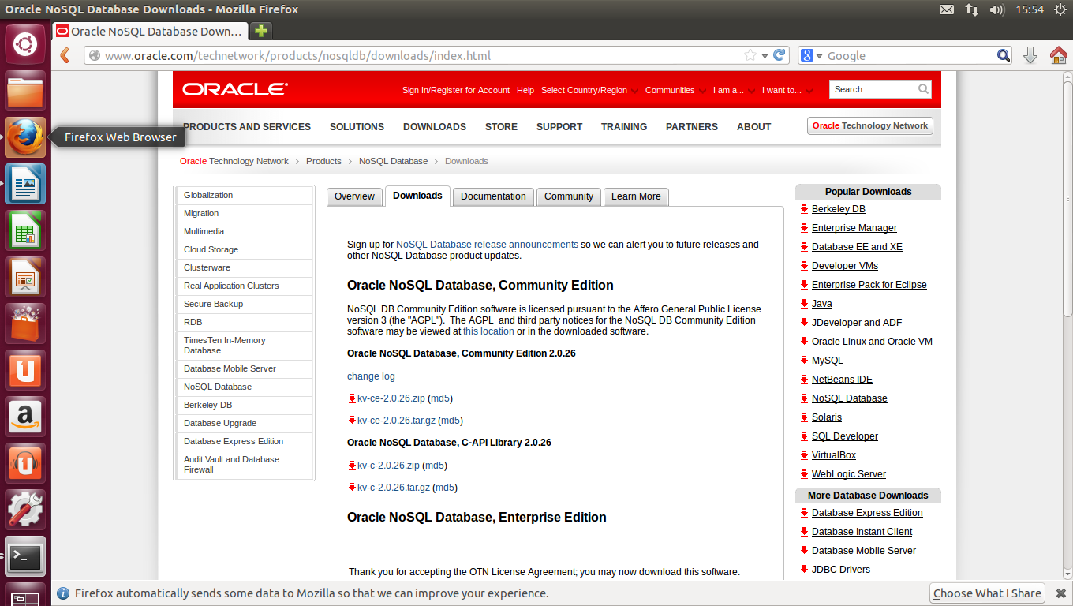fig.1

This is the downloads page for Oracle NoSQL database

http://www.oracle.com/technetwork/products/nosqldb/downloads/index.html

fig.2

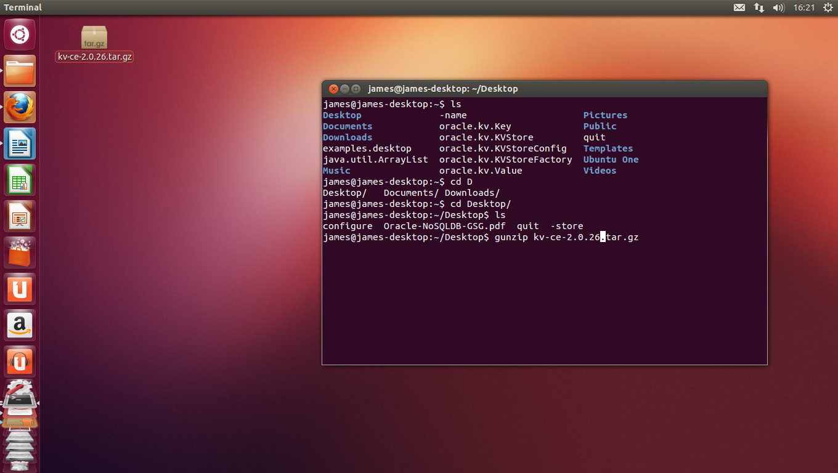

This is the unpacking of the Oracle NoSQL database Community Edition 2.0.26

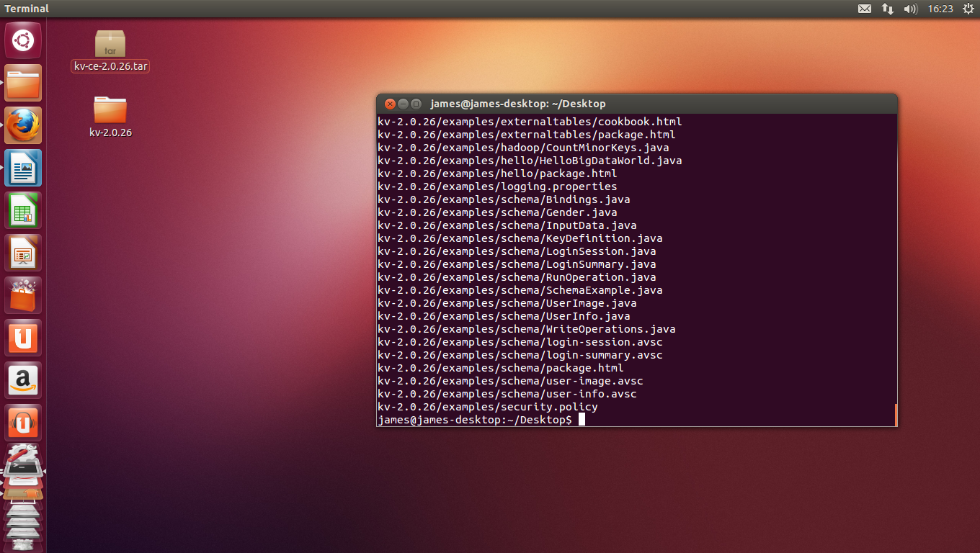fig.3

This is the unpacking of the Oracle NoSQL database Community Edition 2.0.26

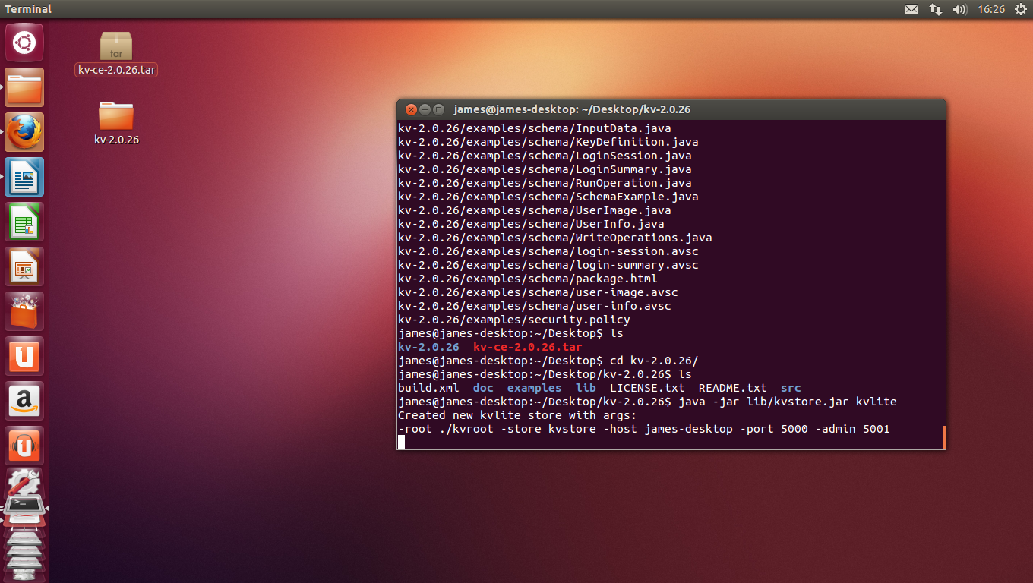fig.4

This is the running of the KVLite process

fig.5

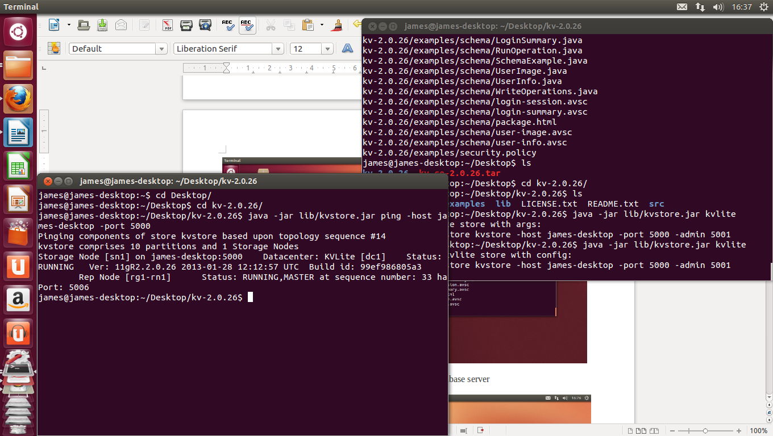

This is the pinging of the KVLite instance

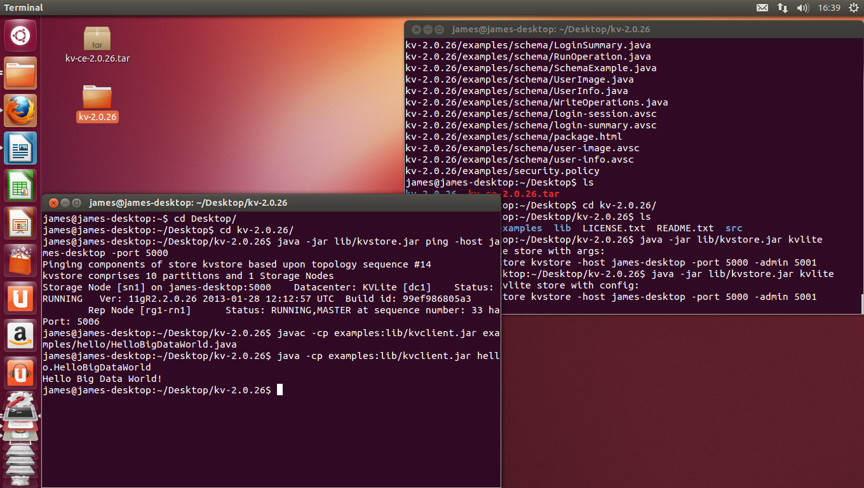

fig.6

This is the compiling and running of the hello world example

fig.7

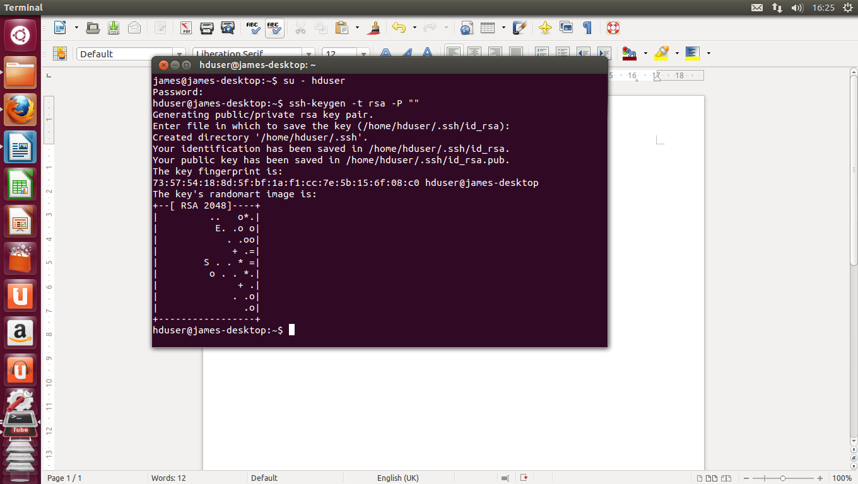This is the generation of an SSH key for the hduser user. The second line will create an RSA key pair, then SSH access to the local machine with this newly created key is enabled.

fig.8

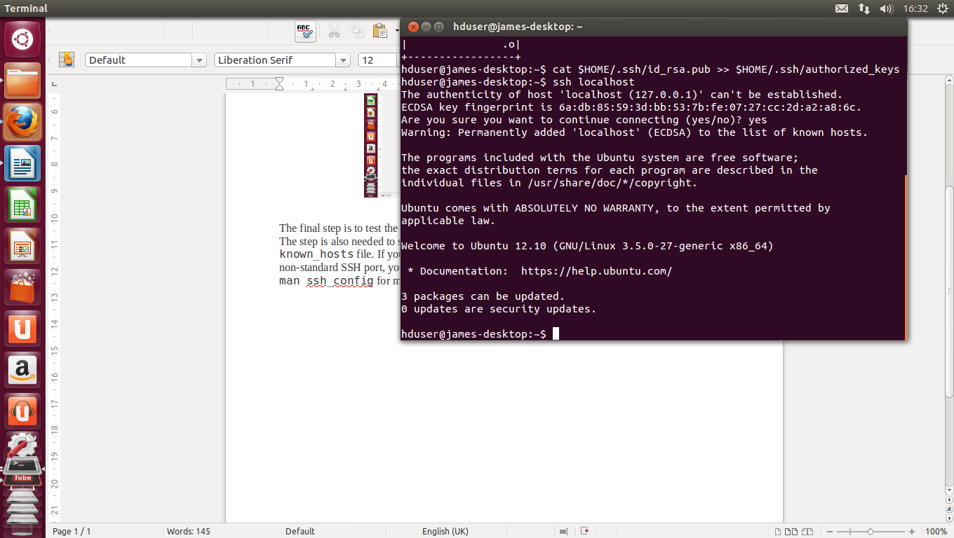

Here the SSH setup is tested by connecting to the local machine with the hduser user.

fig.9

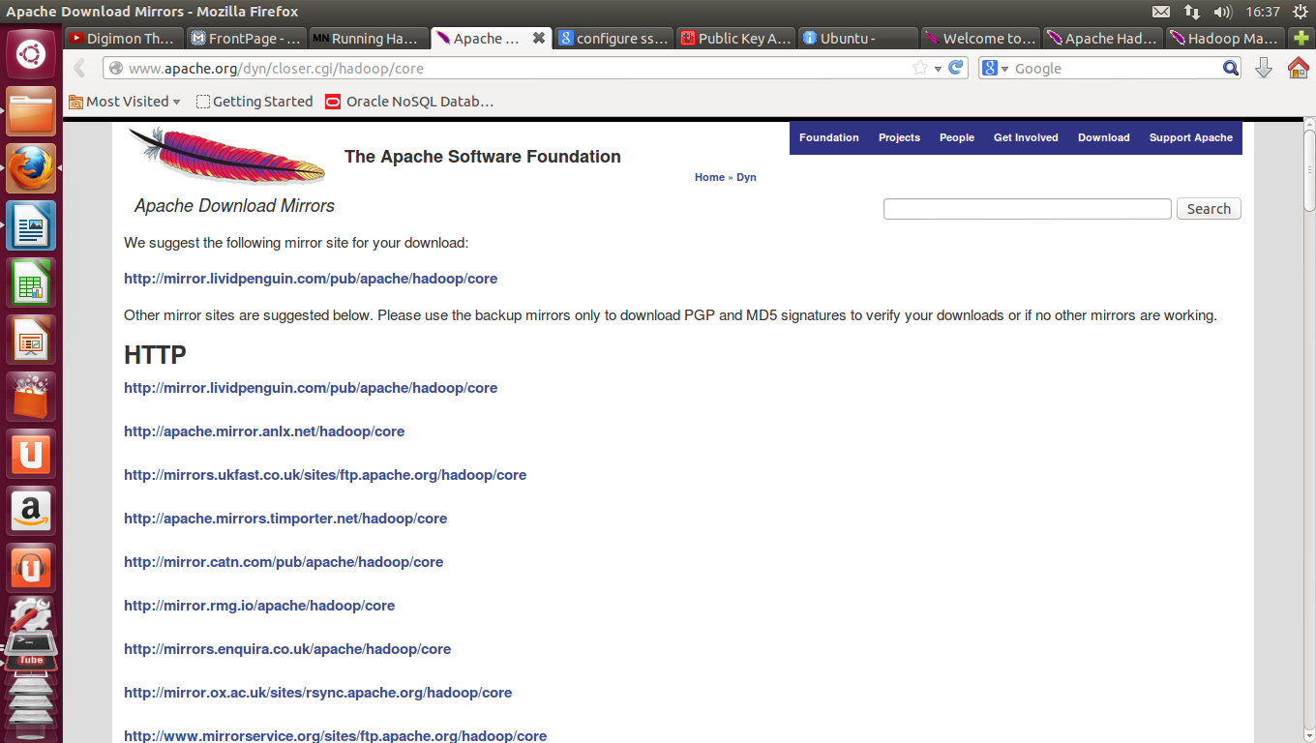Here apache hadoop is dowloaded from one of its download mirrors.

fig.10

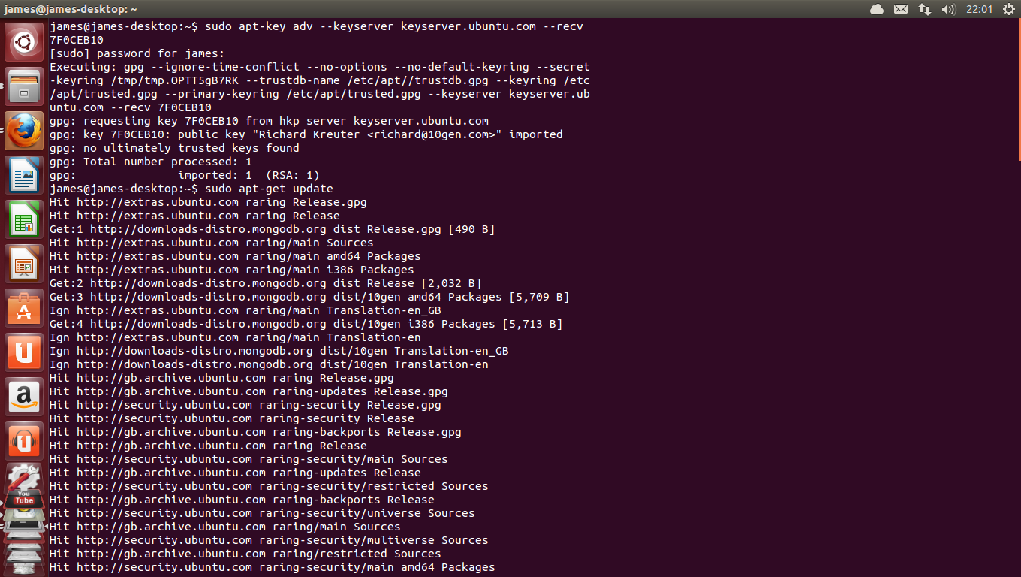

Here the 10gen GPG key was added and the source list updated.

fig.11

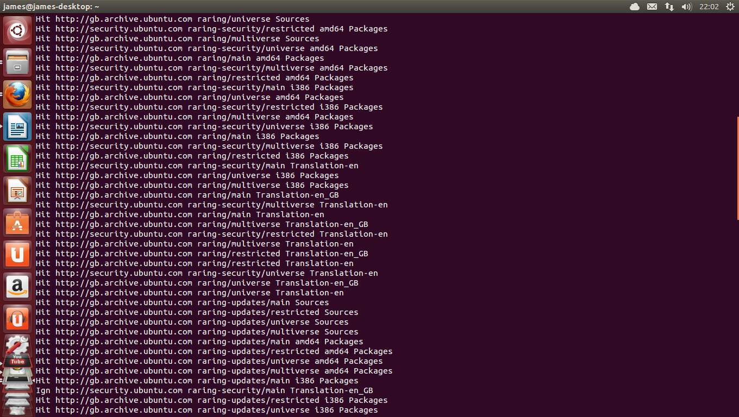

The source list is continuing to be updated.

fig.12

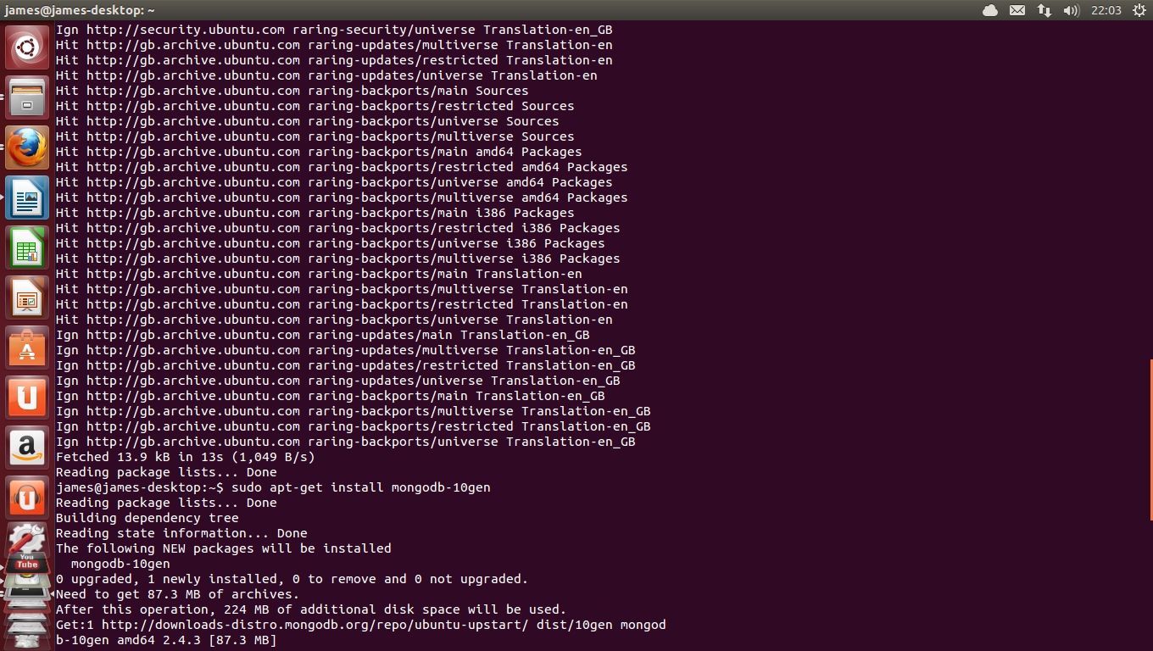

The source list finishes updating and the install of MongoDB begins.

fig.13

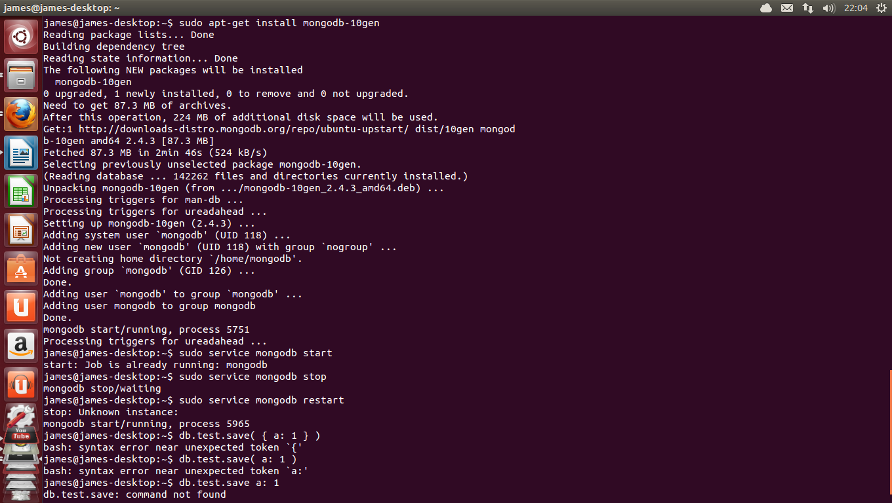

MongoDB finishes installing and the MongoDB service starts.

fig.14

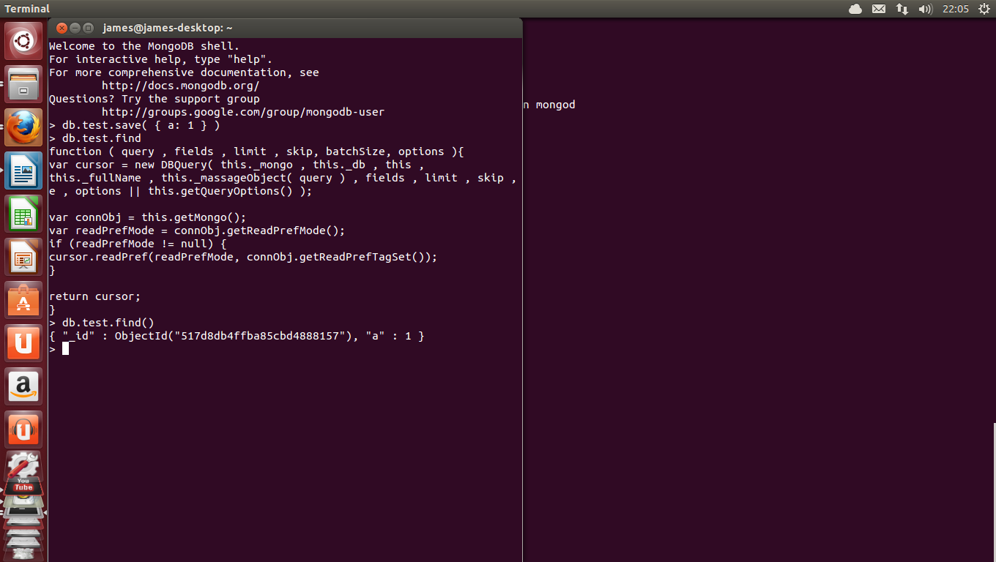

In a second shell a command is given to connect to the MongoDB service, a test record is inserted into the test database and queried to check the installation and connection proceeded as planned.

fig.15

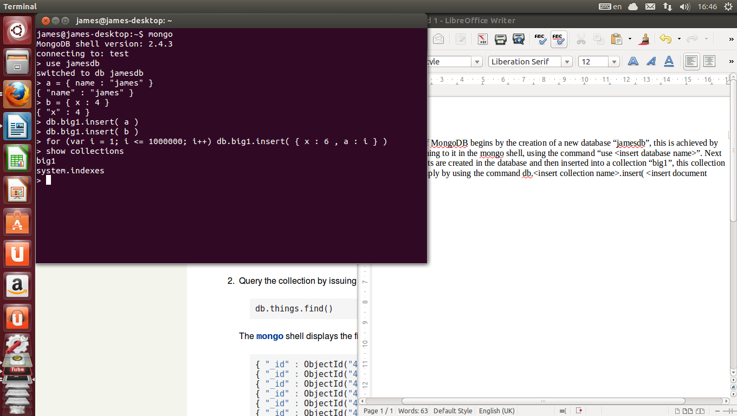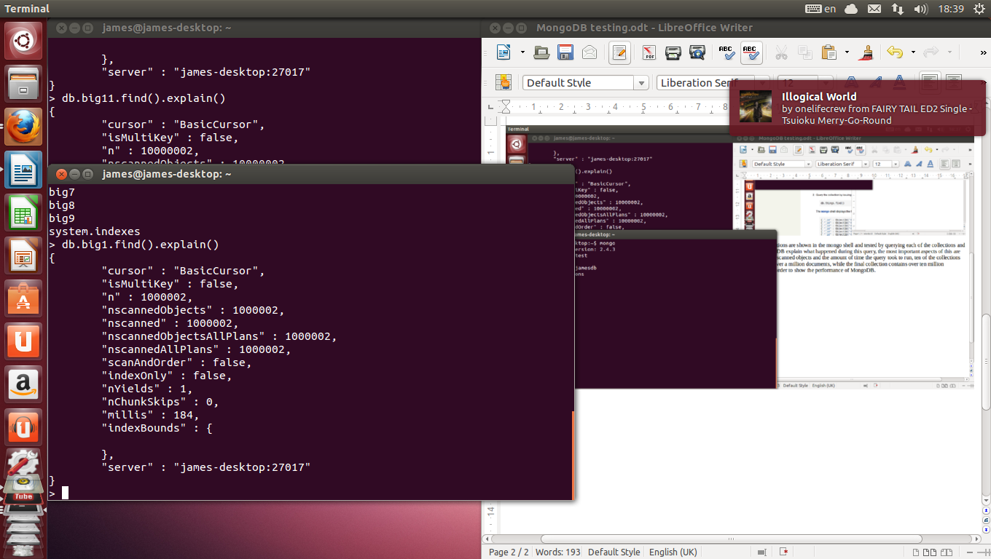The "jamesdb" database is created and a large amount of documents are inserted into the "big1" collection, this same process is repeated for all collections up to "big11".

fig.16

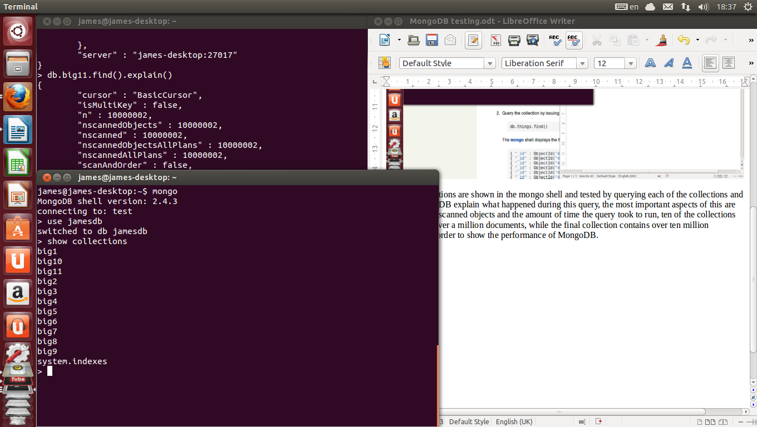

The collections in the "jamesdb" database are displayed.

fig.17

The big1 collection is queried to retrieve all the documents and shows the number of documents

and the time taken.

fig.18

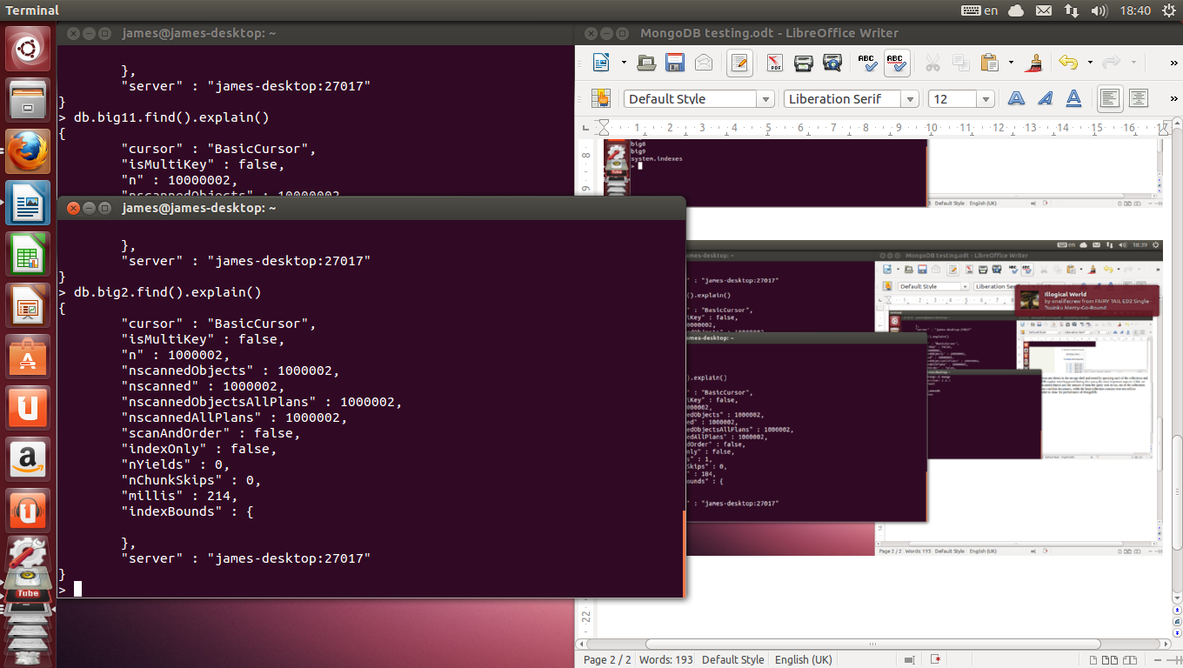The big2 collection is queried to retrieve all the documents and shows the number of documents and the time taken.

fig.19

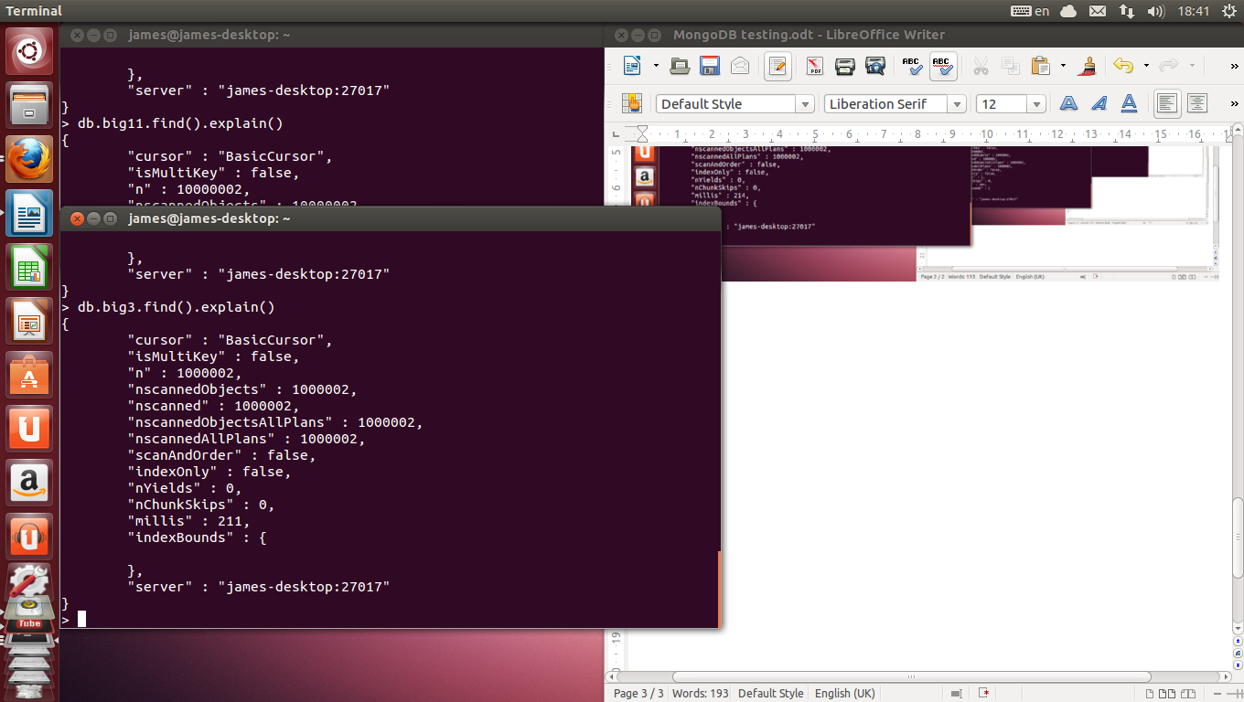

The big3 collection is queried to retrieve all the documents and shows the number of documents and the time taken.

fig.20

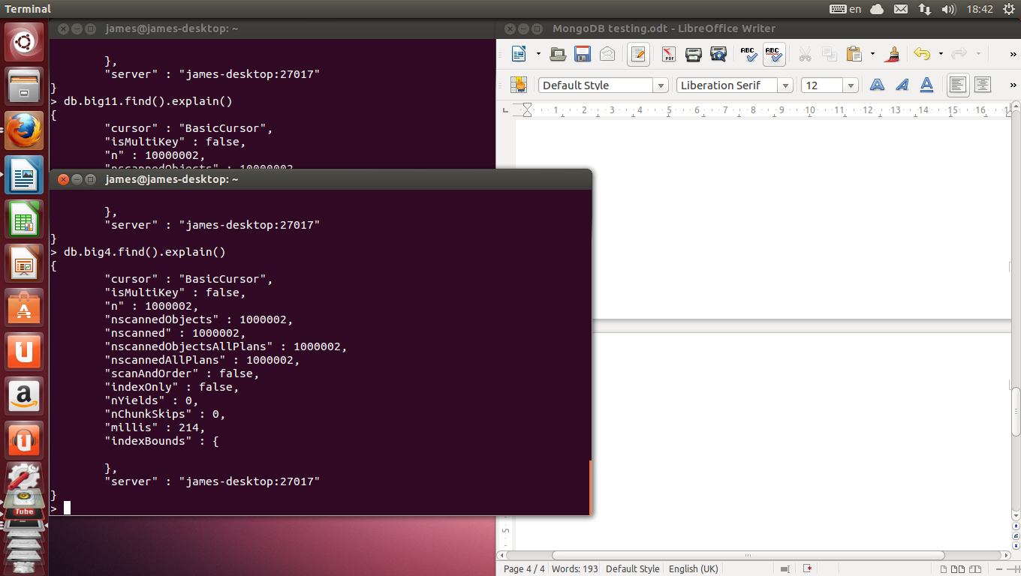

The big4 collection is queried to retrieve all the documents and shows the number of documents and the time taken.

fig.21

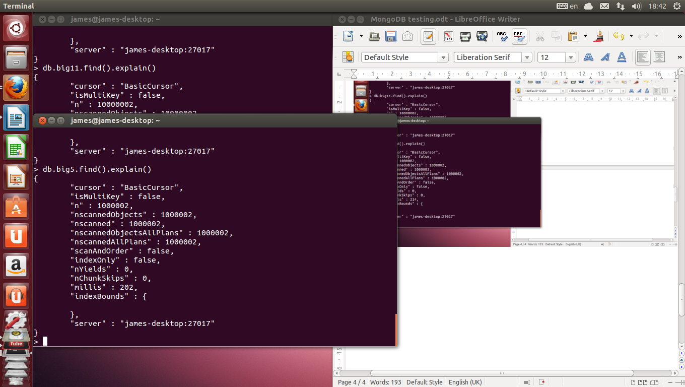

The big5 collection is queried to retrieve all the documents and shows the number of documents and the time taken.

fig.22

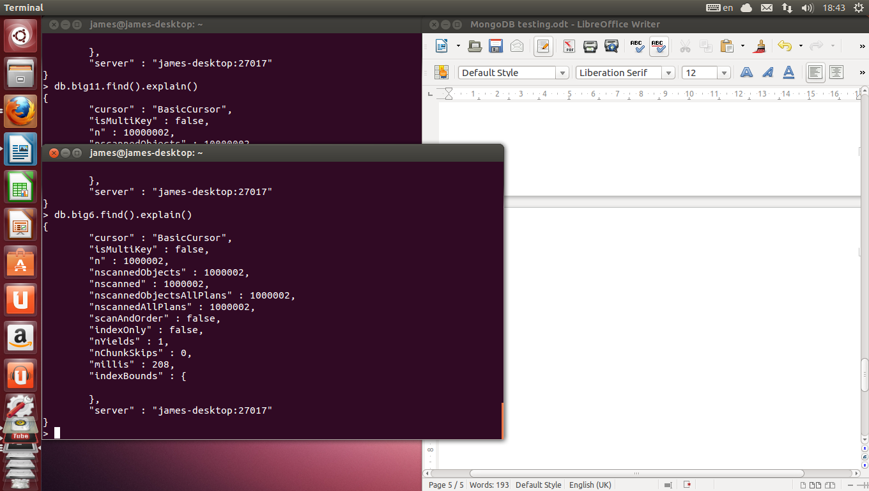

The big6 collection is queried to retrieve all the documents and shows the number of documents and the time taken.

fig.23

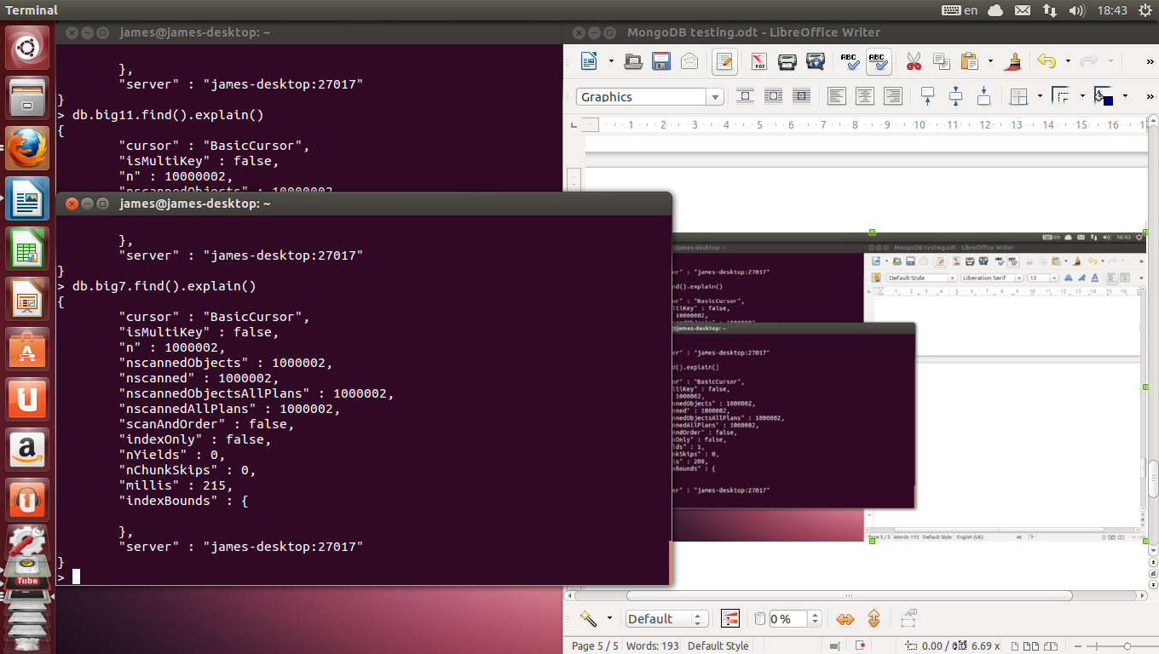

The big7 collection is queried to retrieve all the documents and shows the number of documents and the time taken.

fig.24

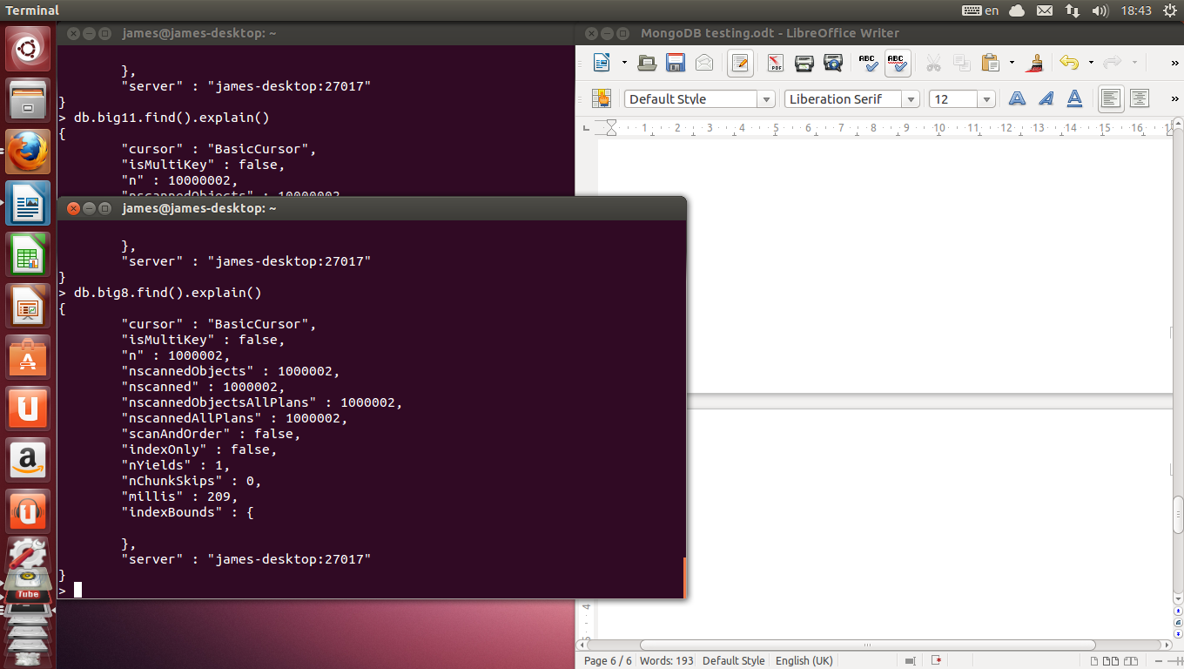

The big8 collection is queried to retrieve all the documents and shows the number of documents

and the time taken.

fig.25

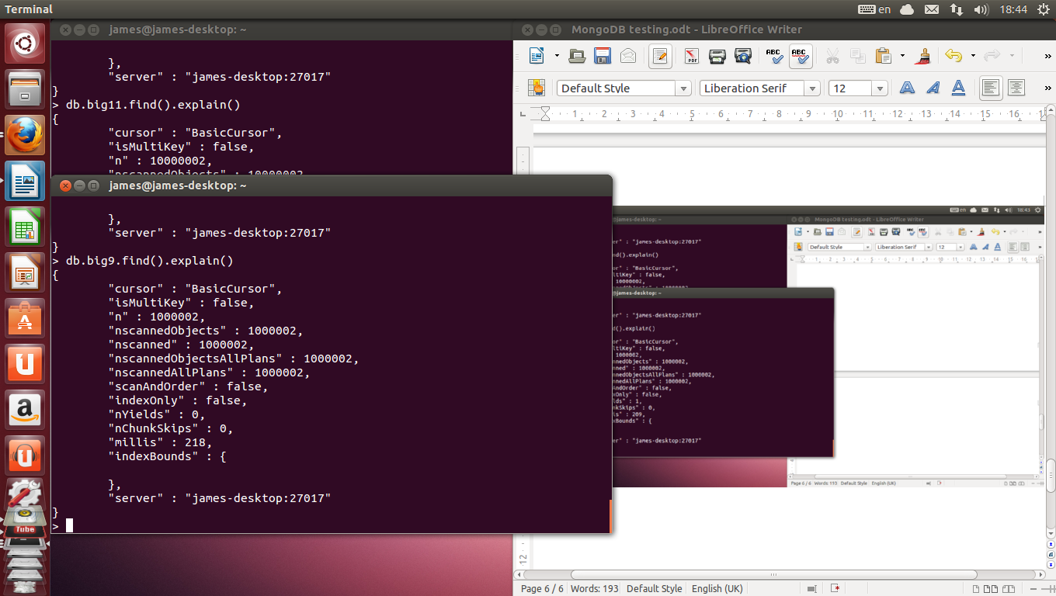

The big9 collection is queried to retrieve all the documents and shows the number of documents

and the time taken.

fig.26

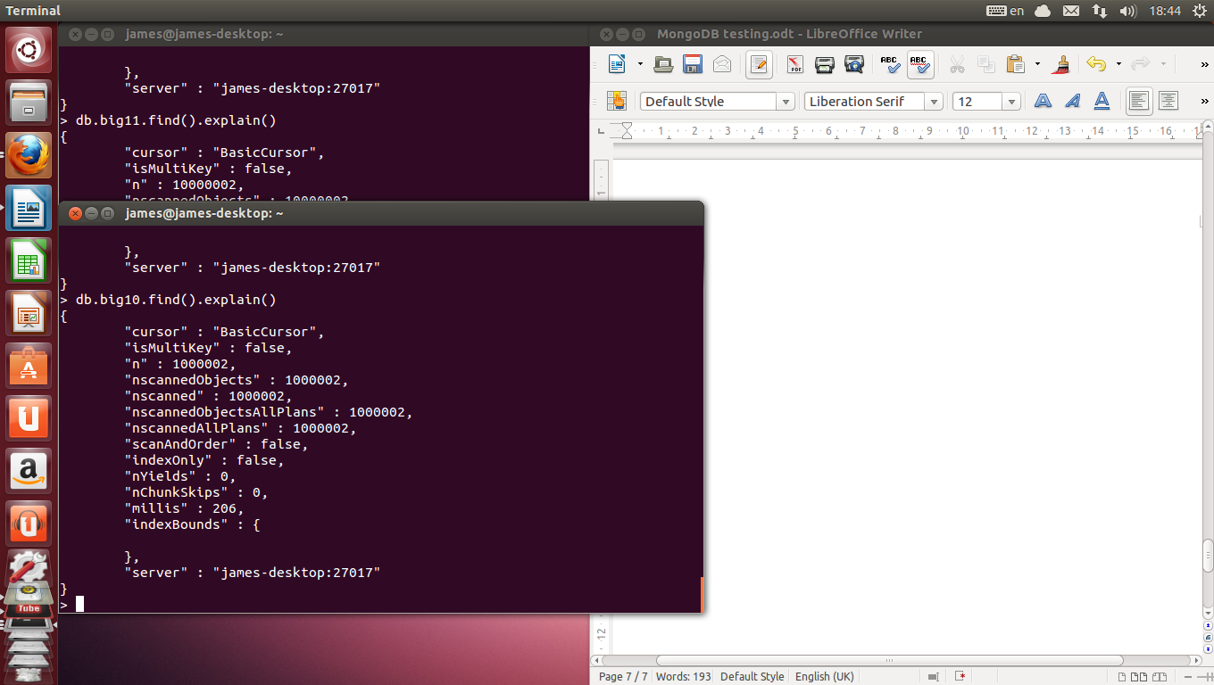

The big10 collection is queried to retrieve all the documents and shows the number of documents

and the time taken.

fig.27

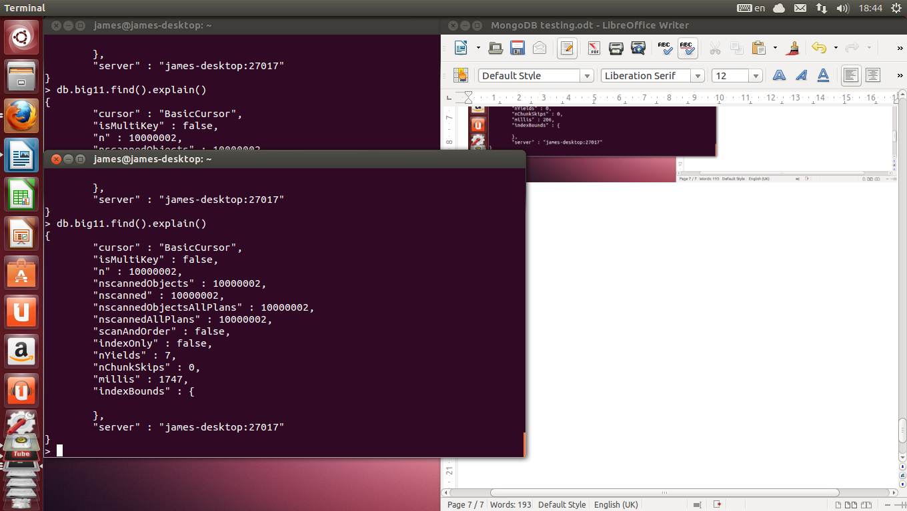

The big11 collection is queried to retrieve all the documents and shows the number of documents

and the time taken.

fig.28

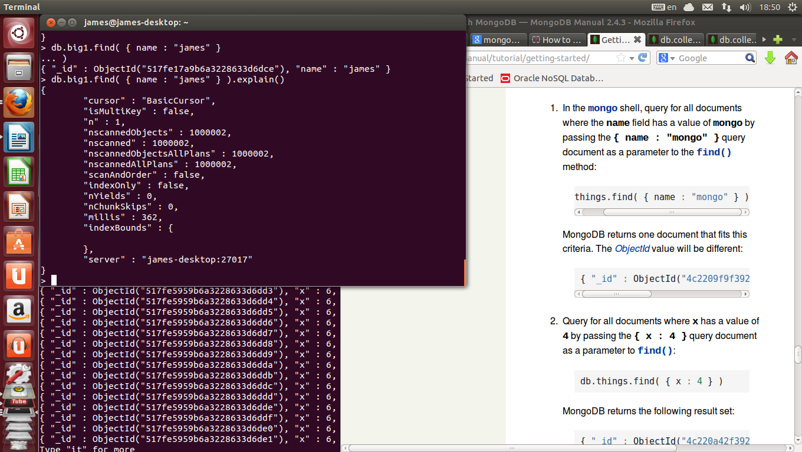

The big1 collection is queried to retrieve the documents that meet the specifications of the query and shows the number of documents

and the time taken.

fig.29

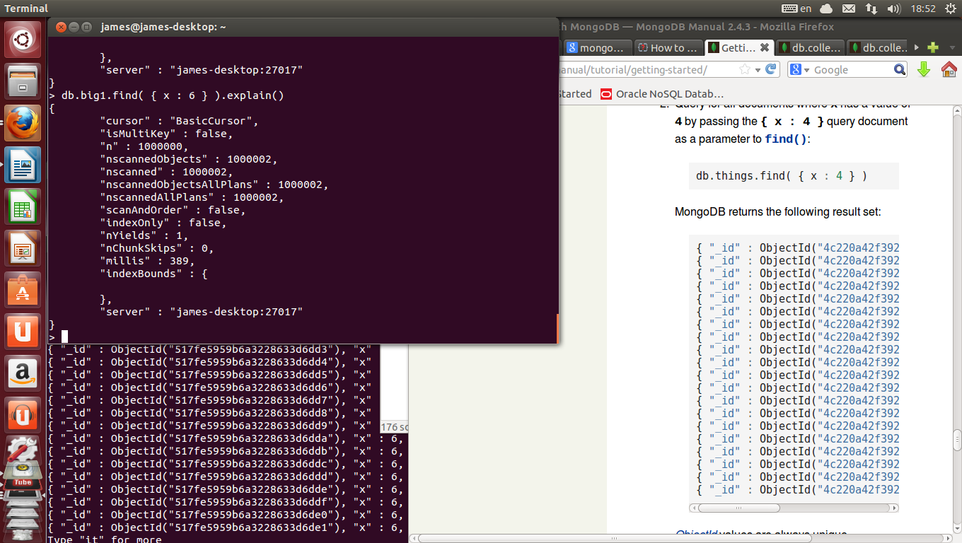The big1 collection is queried to retrieve the documents that meet the specifications of the query and shows the number of documents

and the time taken.

fig.30

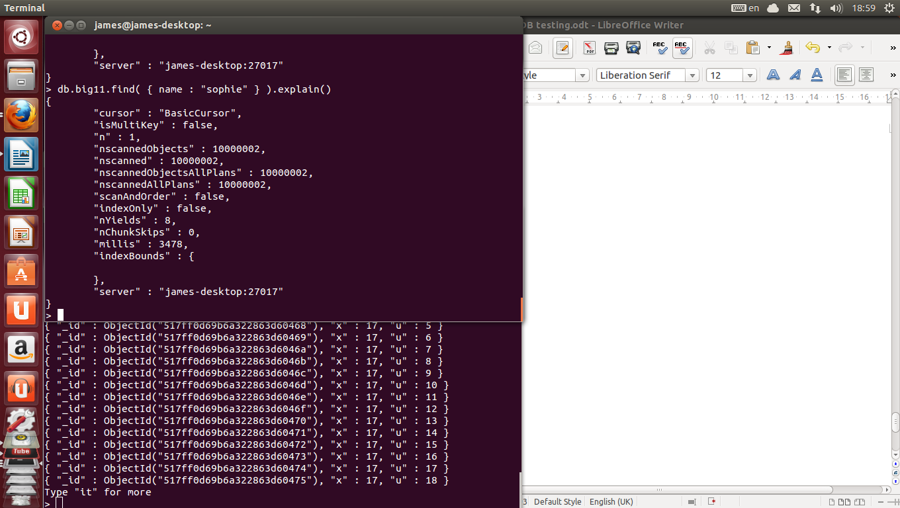

The big11 collection is queried to retrieve the documents that meet the specifications of the query and shows the number of documents

and the time taken.

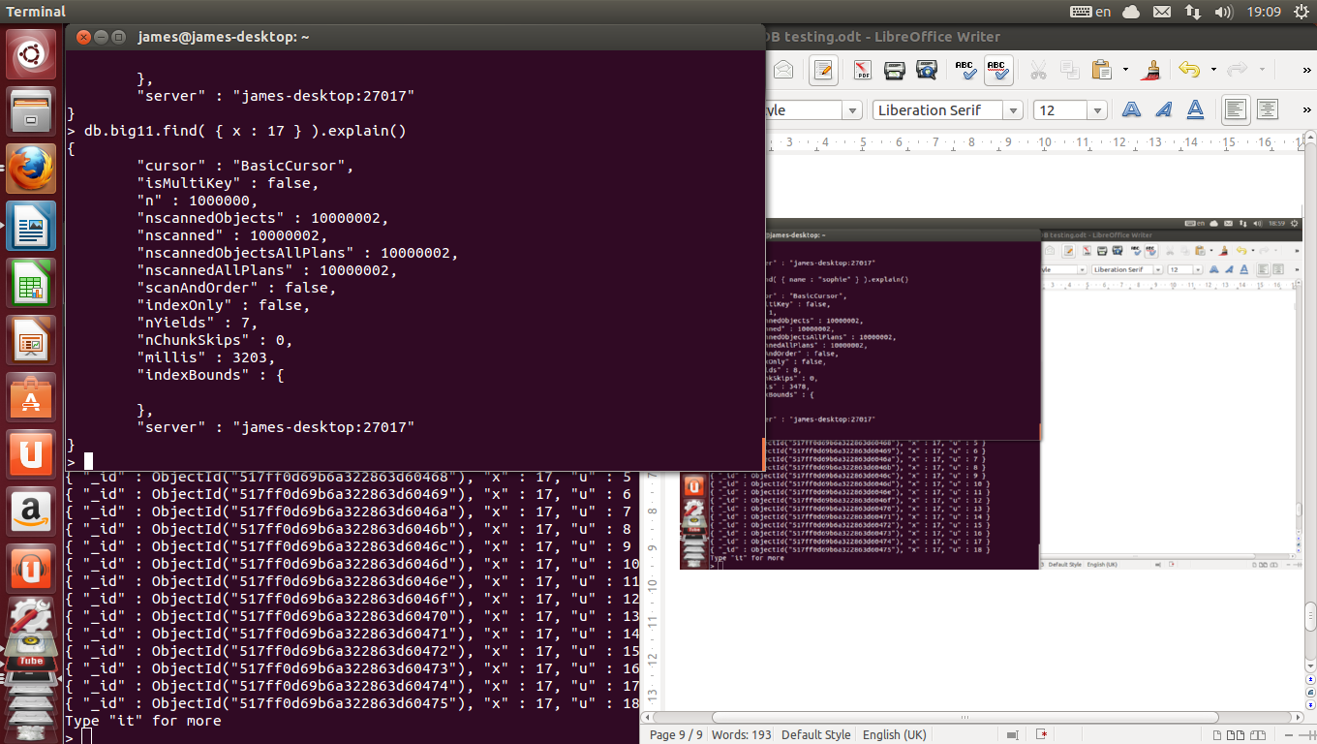fig.31

The big11 collection is queried to retrieve the documents that meet the specifications of the query and shows the number of documents

and the time taken.

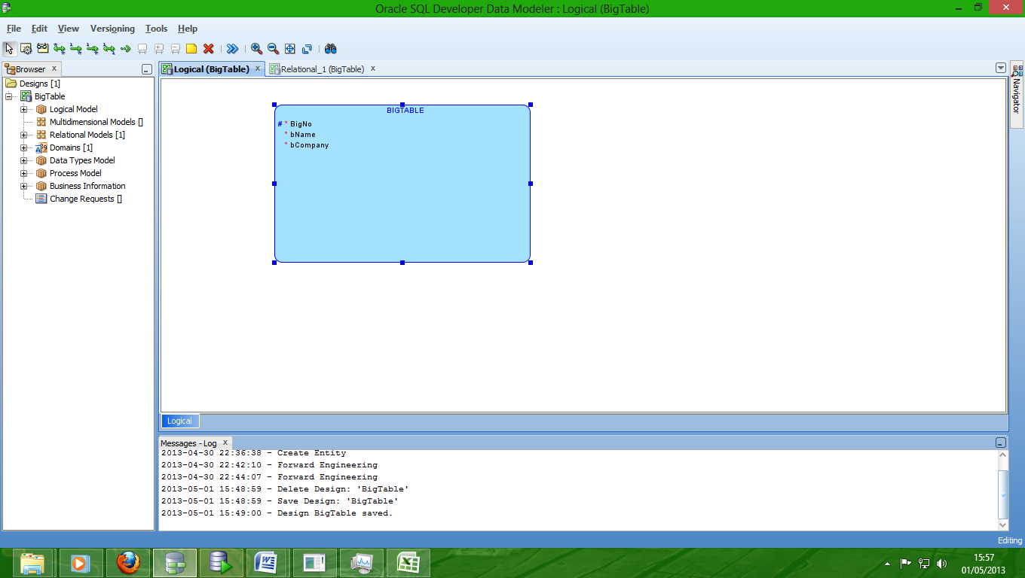fig.32

This is the logical model of the BigTable table.

fig.33

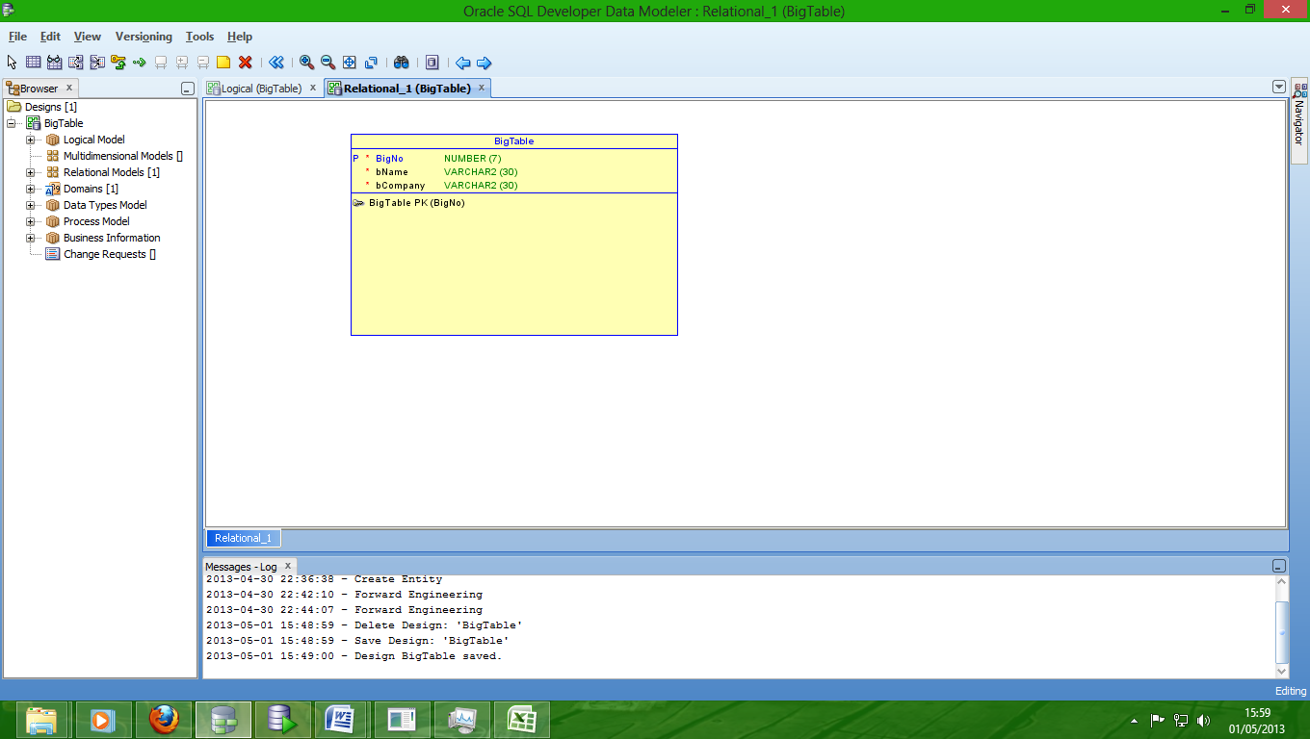This is the relational model of the BigTable table.